The #Refugeecrisis in the EU

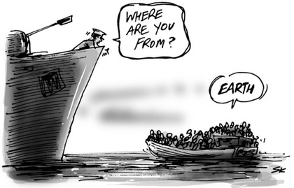
What Does This Cartoon Mean?

