The #Refugeecrisis in the EU

Will he get past the UK border patrol?
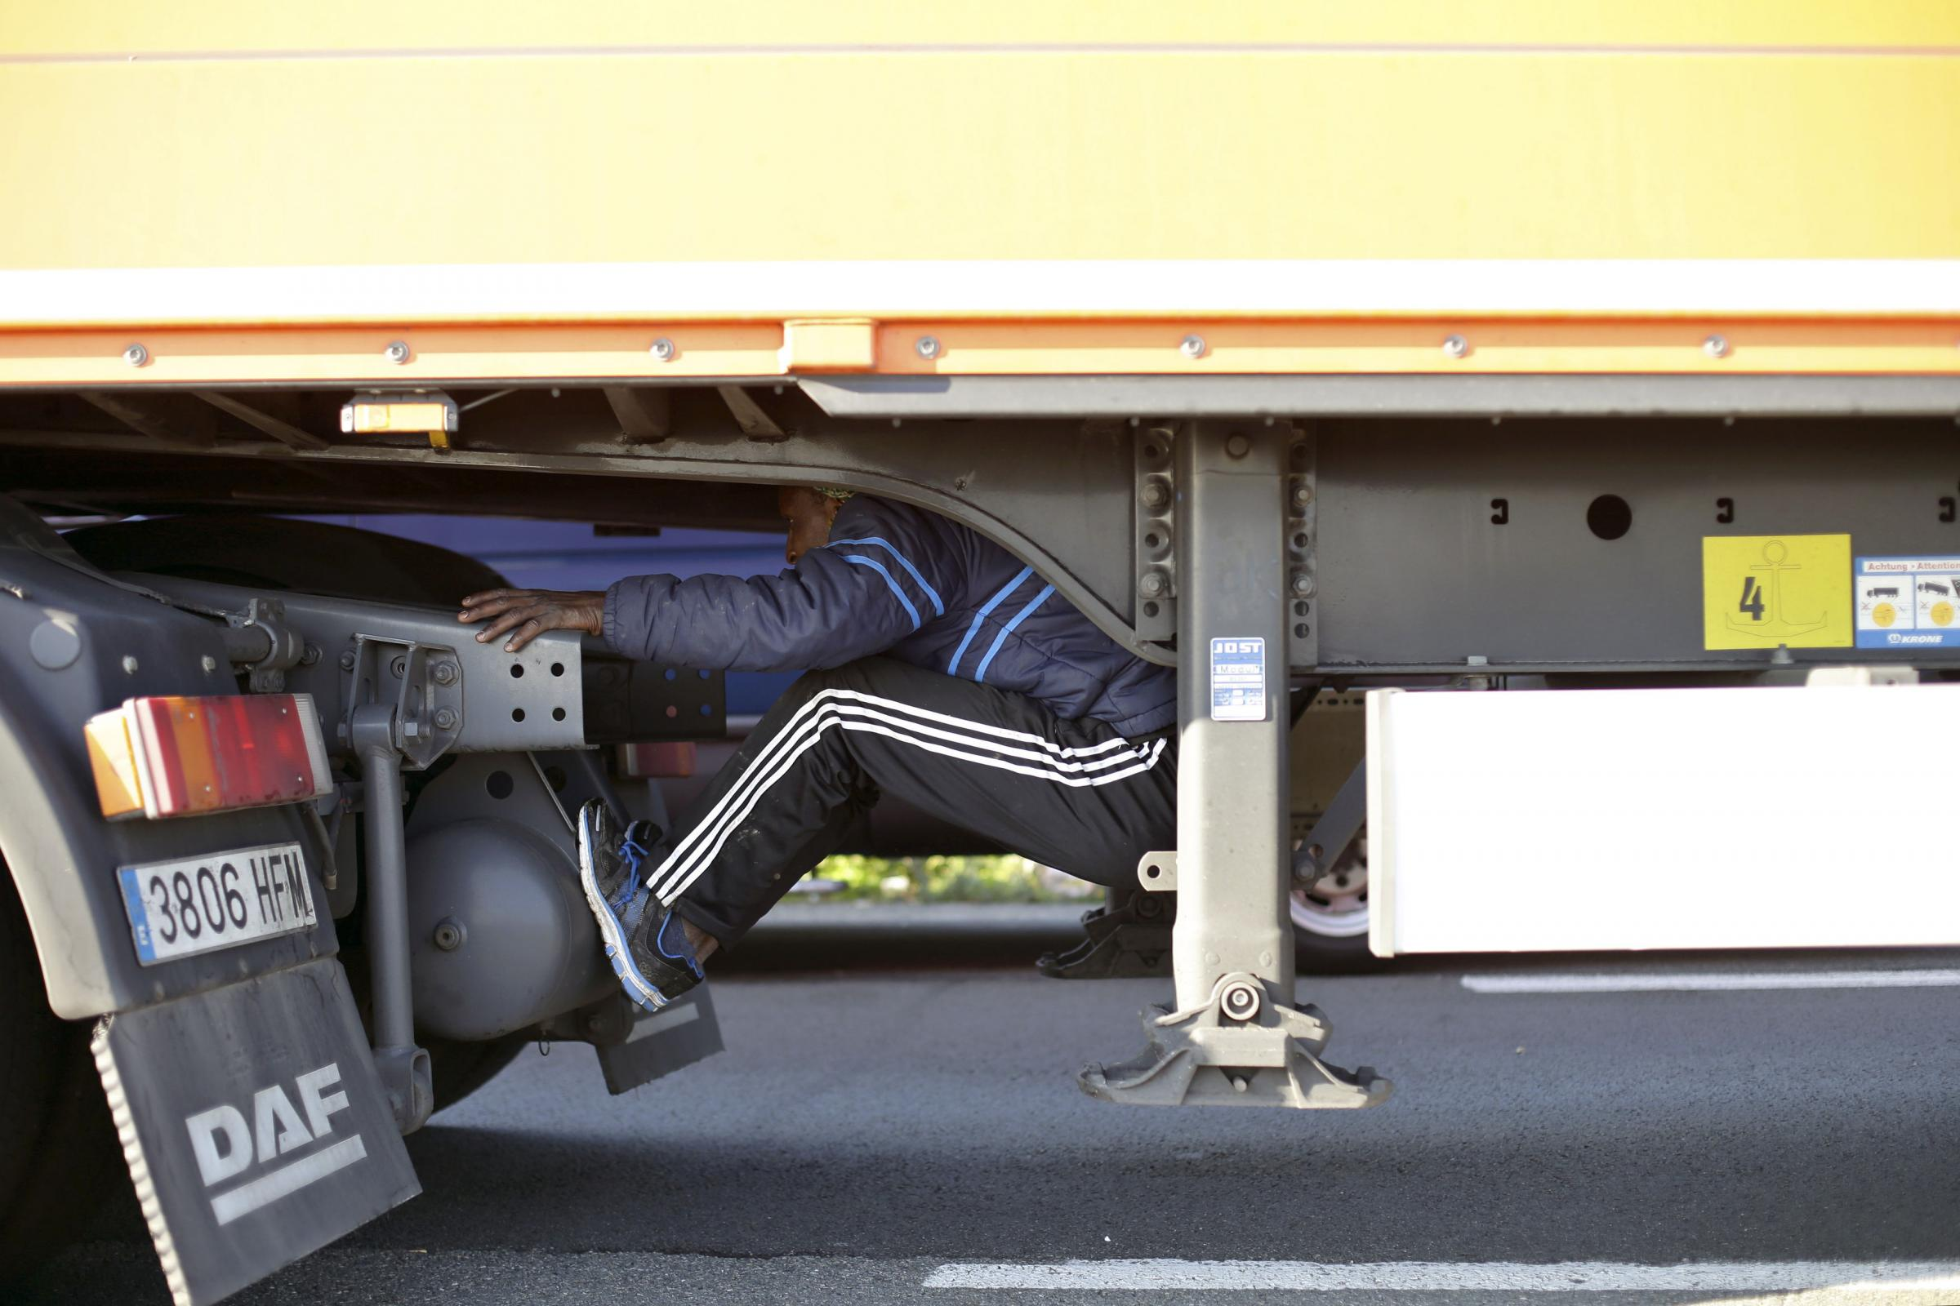
What happens if he’s caught?

