The #Refugeecrisis in the EU
Are they lucky or unlucky?
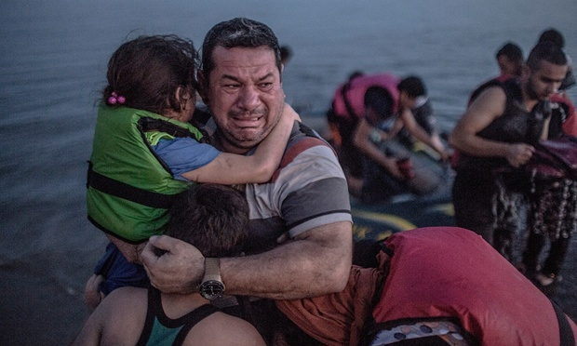
What will they need in the next 7 days?

