|  |
| --- |
| **IGCSE Geography – Middle Course of the River Garonne – Student Case Study Sheet** |

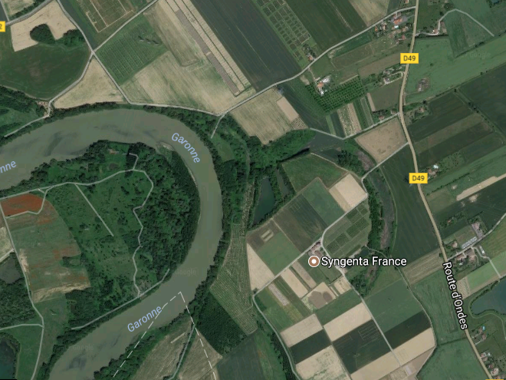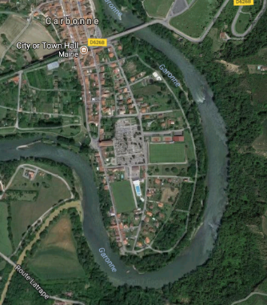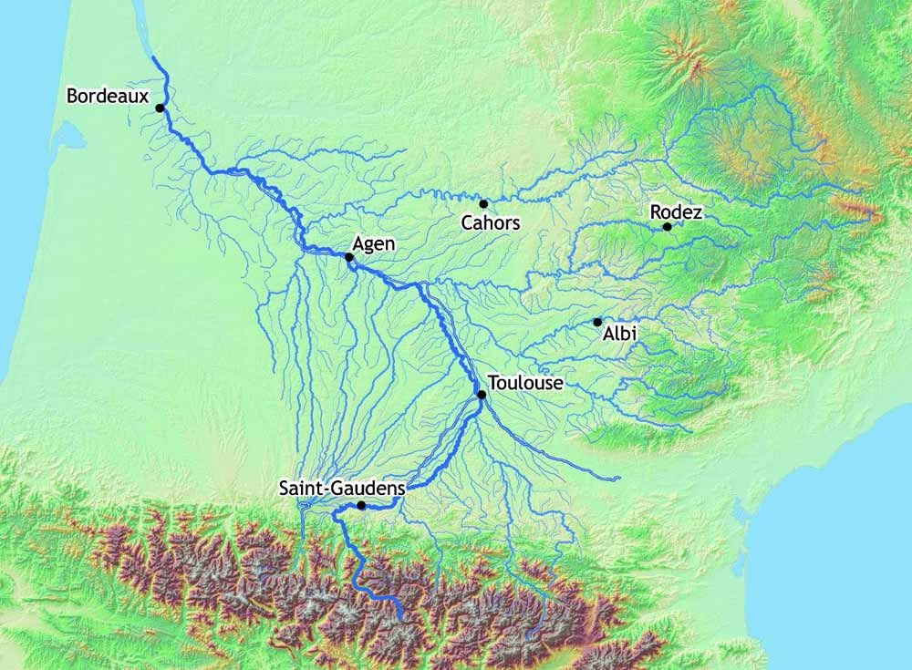

Label

Label

Label

Label

Label

**Task 1** – Describe how a meander is formed

Oxbow (billabong) lake formation diagram

Meander formation diagram

