International Water Conflict
My teacher: Effort ________/20 IB Level ______
USA / Mexico Conflict – My IB One2One Lesson

Location: Annotate on the river and the zone of conflict
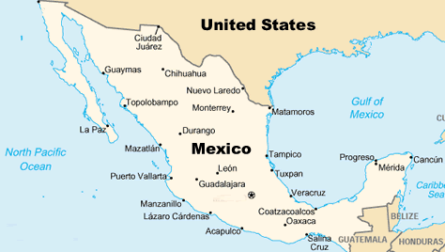

Why?

Key data

What?

Key data

Where?

Key data

Management Strategies

Key data
When?

Key data

Key data

Who?

Key data

