IGCSE Geography – International Migration Mexico to USA
To start with, watch the Walls of Shame two part documentary on geographypods.

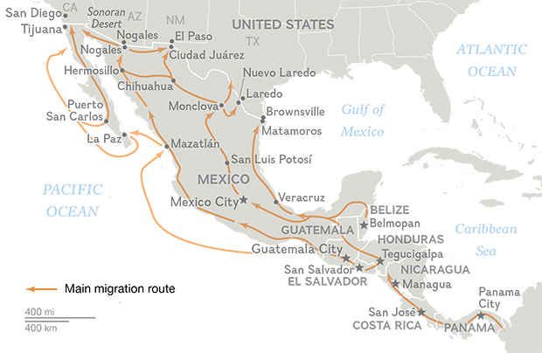
Task 1 – You’ll hear the Sonoran Desert being mentioned at the start of the video as a place that migrants that often cross on their journey to the USA. Highlight the desert area on the major migration route map above.

Task 2 – Listen to the migrant from 4.50 who has been left behind. Annotate around the photo below all the dangers he faced on his trip traveling through this dangerous area.

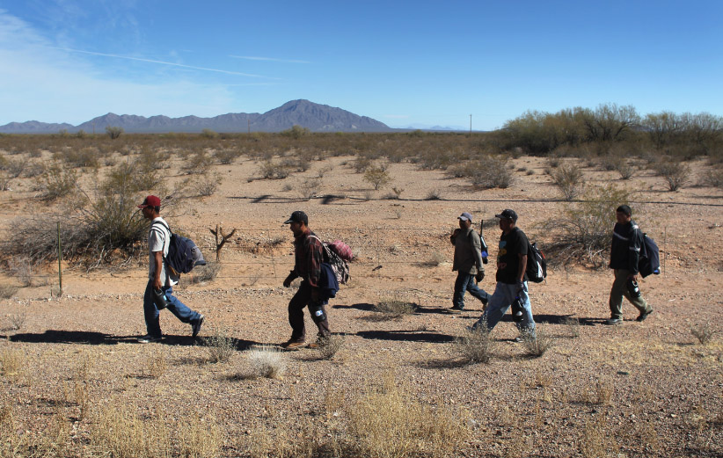

Task 3 – At 8.05 you’ll hear the interviewee talking about the mixed messages coming out of the United States. Explain what she means by these mixed messages.

Task 4 – 8.47 - Since the year 2000, how many Mexican migrants have entered the USA each year and how many does this now total?

Task 5 – 9.40 - Why have the walls that have been built been ineffective?

Task 6 – 10.20 - How does the Mexican Government benefit from the migration situation? You’ll hear the word ‘remittances’ being mentioned. What does this mean?

Task 7 – At the start of the second video, outline the major ‘pull’ factors attracting the migrants to the USA.

Task 8 – Annotate around the security camera image below the ways in which border control aim to stop the flow of Mexican Migrants into the USA.

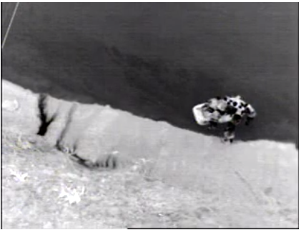

Task 9 – 17.50 - Outline the job of a ‘Coyote’ as interviewed in the documentary.

So, why move? What does the data tell us?

Task 10 – Using Google Data Bank / CIA WFB etc, find the most up to date developmental data for the USA & Mexico and fill in the table below. Please also work out the difference in the final column.
 | MEXICO | USA | Difference
Fertility Rate

Life Expectancy

GDP PPP (per capita)

Literacy Rate

Murder Rate (Wikipedia)

Unemployment Rate % of working age population

Task 11 – From what you have seen so far, write down five push and five pull factors in the space below in terms of migration from Mexico to USA.
Push | Pull

Task 12 – Annotate the Lee’s Migration Model with details that you have picked up over the course of this mini study as well as the link available from geographypods.

Socio Economic Impacts of Migration
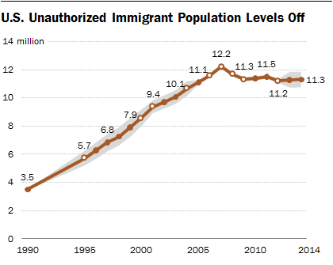
Task 13 – Using the graph above, describe the pattern of total number of unauthorized immigrant population in the USA between 1990 & 2014.

Task 14 – Using the link on geographypods, please complete the table beneath outlining the impacts of migration on both the USA (destination) and Mexico (origin)
Social Positive | Social Negative
Economic Positive | Economic Negative

Exam Corner – Choose one of the questions to answer below:

- The migration of people can be explained in terms of the pull and push factors which influenced their decision to migrate. Choose any example of migration and name the areas between which people moved. Explain why many people made the decision to migrate. You should refer both to pull and to push factors (7)

- Describe the positive and negative effects which the migration of large numbers of people may have on the area to which they move (5)

