IB DP Geography – Leisure at the local Scale – Rural Tourist Attraction Machu Picchu - Name:
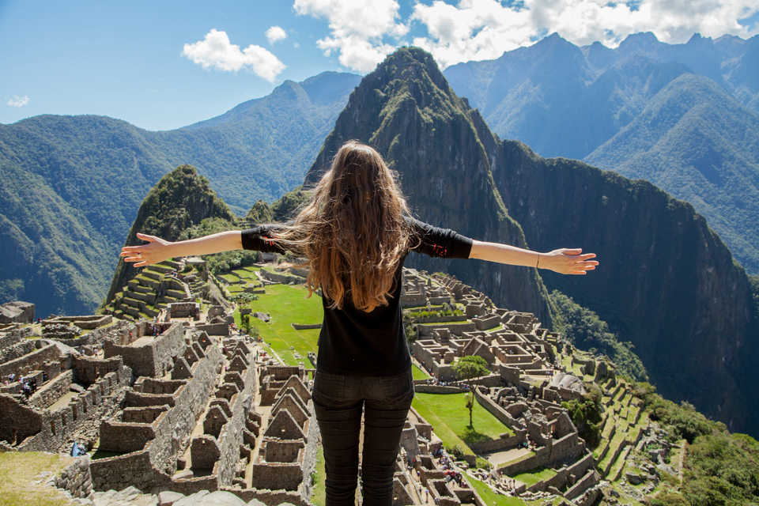
Task 1 – Brief history of Machu Picchu in less than 50 words.
Task 2 – Mark on the location of Machu Picchu and note the location below.
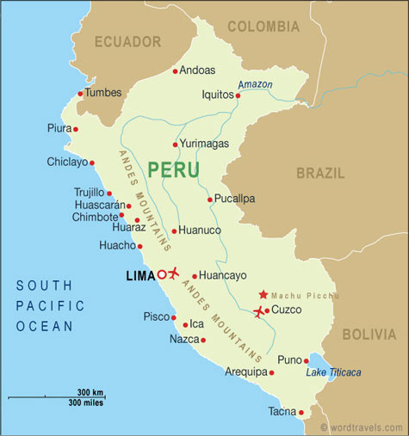

Task 3 – Outline the main features of the Programa Machu Picchu,

Task 4 – Outline the main features of the Management of the Inca Trail

Impact Factors | Benefit | Cost
Social | 1  2 | 1  2
Economic | 1  2 | 1  2
Environmental | 1  2 | 1  2
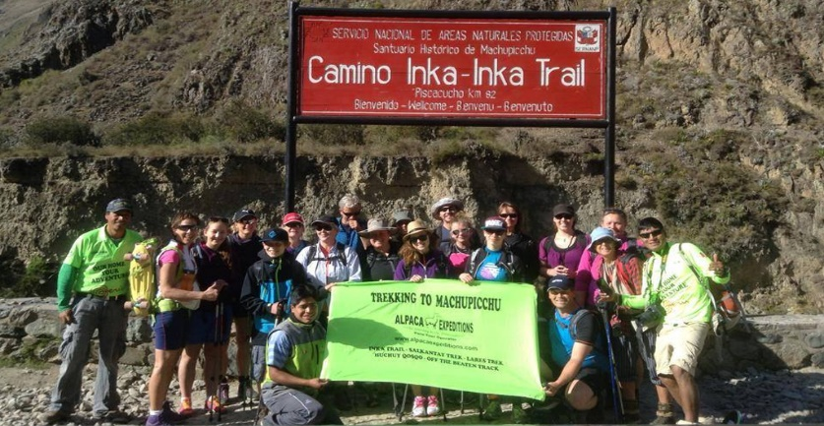
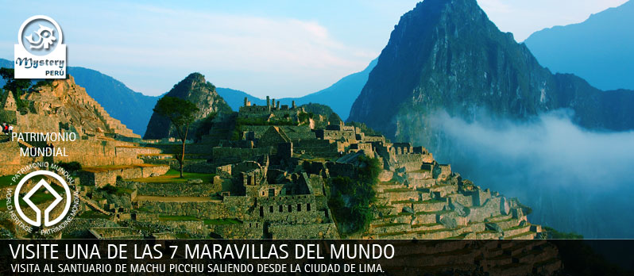

Top 5 reasons pro management plan | Top 5 reasons against management plan
1  2  3  4  5 | 1  2  3  4  5

Exam Practice: Referring to one example, discuss the strategies that may be used to maintain the carrying capacity of a popular tourist attraction in a rural area (10)

