Long Profile – River Garonne
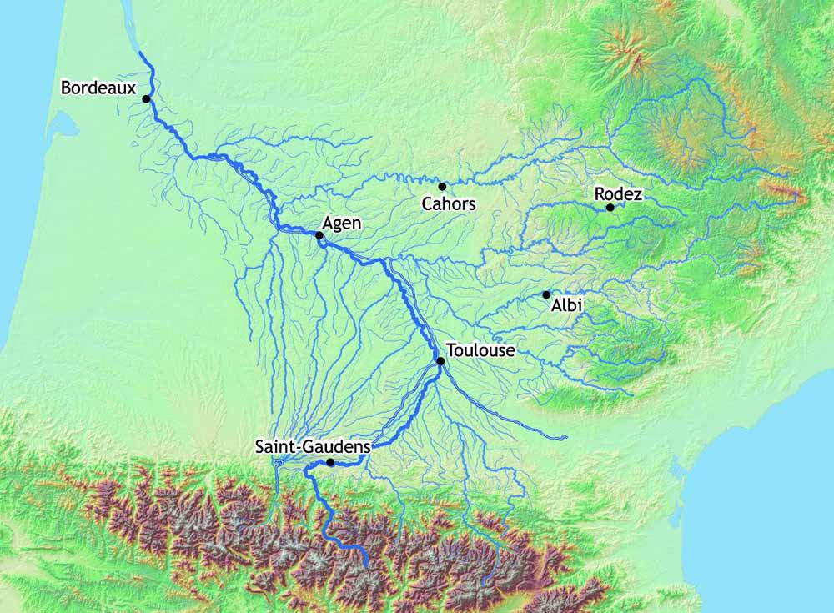
Locational & River Course Information

The Garonne has its source 2600 metres up in the Spanish Pyrenees above the town of Vielha. The river takes a North West course through the Pyrenees before turning east towards the settlement of Saint-Gaudens ….

