IB Geography – International School of Toulouse

5. Leisure at the national/regional scale: Sport

Case study of a national sports league – Explain the hierarchy of a league and the location of its teams. Examine the relationship between team location and the residence of it supporters.

Case Study – Ligue 1 Football, France.

Ligue 1 or Le Championnat is the premier division in France in which 20 different clubs compete. These 20 clubs are spread over mainland France and play 38 league games per year. This lesser known European domestic football division will provide us with our case study for this section of the syllabus.


Over to you:

Log on to your computers

http://en.wikipedia.org/wiki/Ligue_1
http://www.ligue1.com/ (English version)
http://www.lfp.fr/ligue1/ (French version)

Task 1 - Setting the scene.
Use the information available to introduce Ligue 1. Approach this as if you were explaining it to an examiner at the start of a question about the league. Target 100 words.

Task 2 - Locating the Teams
Using the web link underneath. Create a map to show the locations and names of each of the current French Ligue 1 teams. Comment on the spread of teams in France. Comment on any patterns, links with cities, rural area coverage etc.

http://fr.soccerway.com/national/france/ligue-1/20142015/regular-season/r25141/map/?ICID=PL_3N_09

Task 3 - Prior Hierarchy of the Teams
Go to the following web links and make a note of the Champions, runner up and third placed finisher for the last 5 seasons.

http://en.wikipedia.org/wiki/List_of_French_football_champions#Championships_by_club

Compare this to the table that shows overall winners of the Ligue 1 since it was set up. Who is the most successful Ligue 1 team of all time?

Task 4 – Attendances and popularity

http://www.ligue1.com/ligue1/affluences/journee

This is the average number of spectators so far this season in Ligue 1 for each club. You need to click on the ‘By Club’ tab at the top to access the table.

Complete a piece of writing about the attendances of the top three clubs (and Toulouse)

Include:
- Name and location
- Population of town/city hosting the club.
- What is the link between attendance and the successes of the club?
- Look at:
- Seasons in Ligue 1
- League titles Won
- First season of current spell in top division. (Target 200 words)

Task 5 – Location, Location, Location

Team location and residence of supporters (Sphere of influence)

You can presume that the vast number of people that turn up on match day will live in the area surrounding the stadium, whether that be in Marseille or Toulouse.

Why is your chosen Ligue 1 team located where it is within each settlement? See the Toulouse FC example on the following page.

You will need to use Google Maps/Earth to locate one of the stadiums (Paris or Marseille are best). Their addresses can be found on the www.ligue1.fr under the club profile. You should take a screen shot of the Google map image and cut and paste into word (don’t forget to source them). Annotate each image to show the relationship between team location and residence of supporters.

This task can be completed in pairs and the work shared at the end.

Example – Toulouse FC
Large residential areas of social housing and apartments within walking distance

Outer ring road. Direct links to Paris, Bordeaux and Montpellier

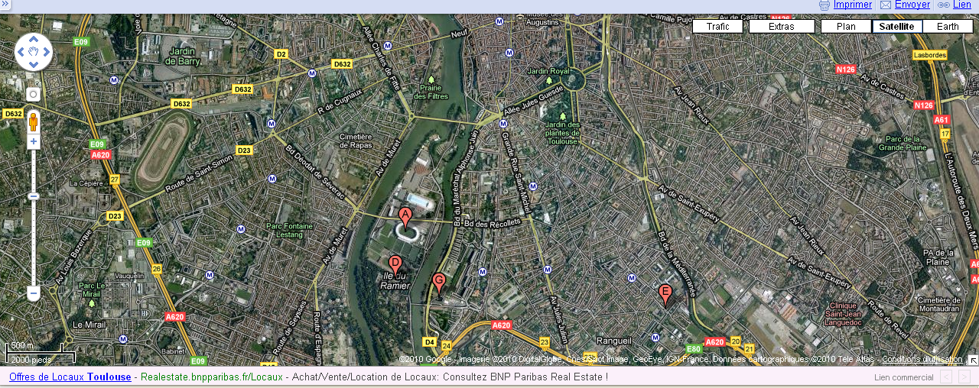

Proximity to major leisure development, swimming pool. Leisure experience.

Stadium location
Public transport links such as the Toulouse metro and bus services.

Inner ring road for ease of transportation to and from the game to those who live outside the city centre

Commentary
Toulouse FC is located approximately 1.5km south west of the historical core of Toulouse city centre. It is located on an island on the banks of the Garonne river. Toulouse city is located in south western France and is a large conurbation of more than 1.5 million people located between the Massif Central and the Pyrenees. The nearest big settlements are Bordeaux: 200 KM north west and Montpellier, 300KM east. The city is served by an international airport and is on the main train line between Paris (north) and Barcelona (south east). The city has a famous sports history with Rugby and football is very much its second sport. The stadium is located very close to the rocade and also close to main bus routes metro links. The majority of fans who live in the city can access the stadium by foot, bus, metro or drive by car. The football club serves the surrounding settlements as far as Colomiers (North West), Muret (south) and Grenade (north).The most famous and successful club in the south of France is Olympic Marseille (400km to the east). Their fan base stretches internationally and many people living in the Toulouse area support this club. Toulouse FC is a relatively small club with an average match attendance of 20,000 people and very limited success. For this reason, they are barely known outside of France and as such cannot attract big name players. Due to this lack of success, they have a small but committed fan base who are from the Toulouse and surrounding Occitane area. There is a clear relationship between the location of the team and the location of its supporters. Only future successes may widen the appeal of Toulouse FC and its national & international fan base.

Task 6 – Supporters away from the town of residence.
You must now find examples of fan bases away from the city of residence and plot these on a world map.

For example: Marseille supporters club – New York, USA. http://www.omnewyork.com/

Complete a short piece of work on why L’OM appeal to fans in the USA.

Task 7 – Exam Question

With reference to specific examples that you have studied, explain the relationship between team location and the residence of its supporters. (10)

Don’t forget to consult the IB mark scheme and planning framework when planning to answer this question.

Well done.

Make sure all work is printed out and placed into your IB Geography folder in the order set out here. The exam question should be submitted for marking.



