G8 Geography - Calculating my life expectancy
Take the test on the BBC article and fill in the information below.
How many more years am I expected to live? | To what age will I live?

By comparison, the opposite sex will live how many more years? | … and to an age of?

How much has the life expectancy for your gender increased since 1990 in your country?

How much of the remainder of your life will you be healthy for?

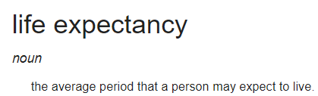

Describe how your life expectancy compares to all of the countries of Africa (click on Africa and look at red lines – each line is an African country).

Where is your home country ranked worldwide? | Where is your country ranked within your continent?

What is the country with the highest life expectancy? | The country with the lowest life expectancy?

What is the global average life expectancy now?
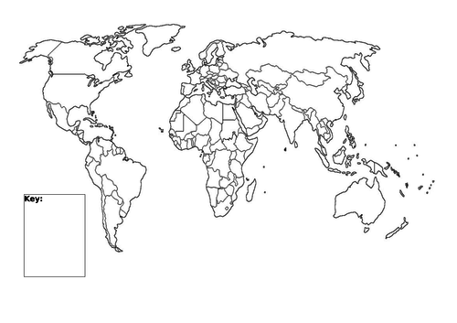

Mark on the life expectancy of your home country, France, the highest & the lowest too.

