G7 Geography – When the Wall Meets the Ocean
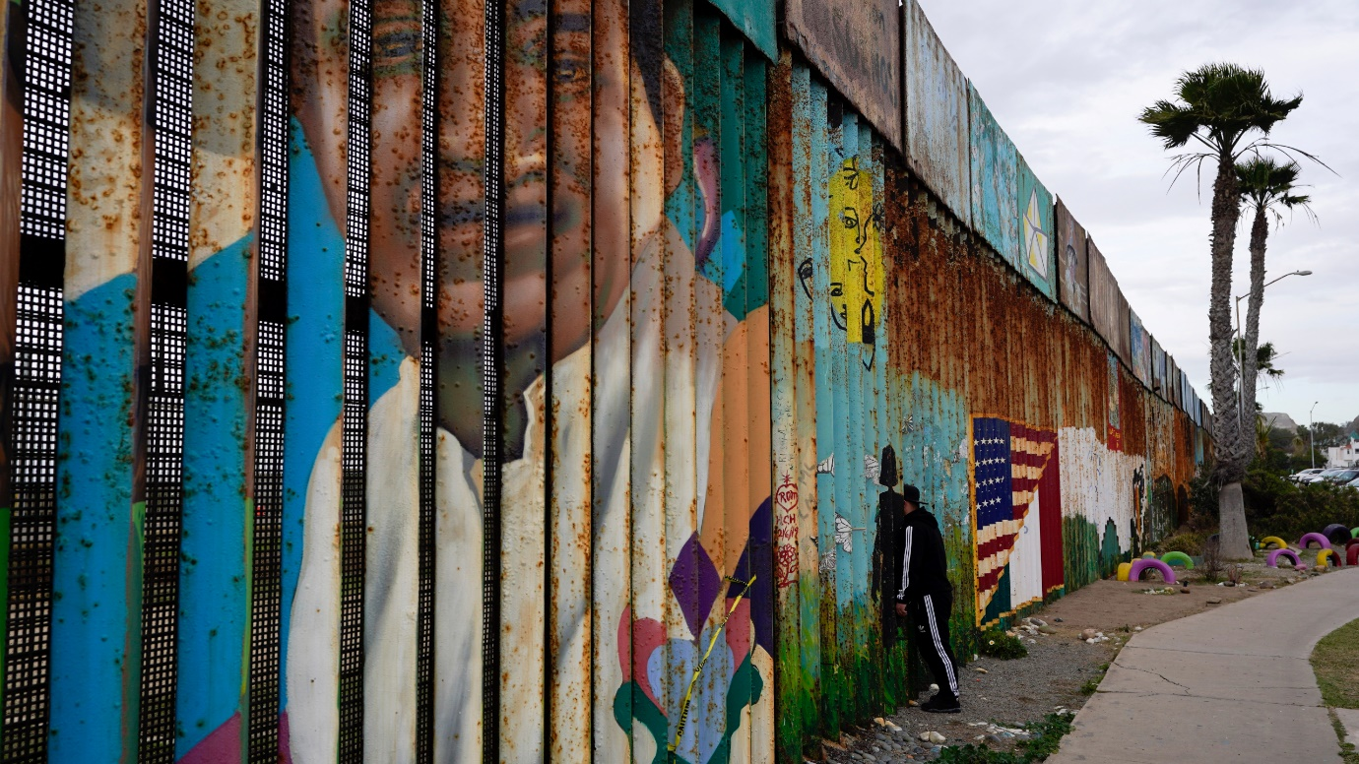
Task 7 - Use the resources embedded on geographypods to complete this section of work. You should have Google Maps open in satellite view and have found the wall between Tijuana and San Diego.

Use the top two Google 360° images on Geographypods and the photo above to complete the next task.

Bio Polar Analysis – The border wall between Mexico and the USA
Barrier Characteristics | Very poor | Poor | Quite poor | No feelings | Quite good | Good | Very good | Total
 | -3 | -2 | -1 | 0 | +1 | +2 | +3
Height
Condition
Well made
Long lasting
Visual deterrent

On a scale of 1 (simple) to 10 (impossible), how easy would it be to cross this barrier and get in to / out of school?
1 | 2 | 3 | 4 | 5 | 6 | 7 | 8 | 9 | 10

What happens when the wall reaches the ocean? Why can’t people just swim around the wall?

Go to the third Google 360° image on geographypods ‘The graffiti – Mexico’. Make the screen full size and turn left and follow the car park to the end. Study the wall carefully and find one graffiti message. (clue – it is written in red).

Paste the phrase below and explain who might have written that and what it means.

Go back to the end of the car park again (or press refresh) and now look carefully at the graffiti images all the way down the length of the car park (start with the girl on the bridge and the girl being carried by balloons).

In the space on the left below, explain why people have chosen to paint these images on the border wall and what they represent. In the column right paste a screen shot of the piece of graffiti you like the most or sketch a copy of it.
Paste screen shot here / sketch copy

Friendship Park & The Door of Hope - Fact File

Using the video on geographypods (The US/Mexico border: Meeting at Friendship Park), and the Google 360° image, complete a fact-finding mission to help you complete a fact file on both the park and the door. Make sure you cover the following.

What is it?
Where is it?
When was it built?
Why was it built?
Who designed it and who uses it?

Complete your factsheet in the space below or on a new Word document.

