Qatar World Cup 2022 – Protest T-shirt
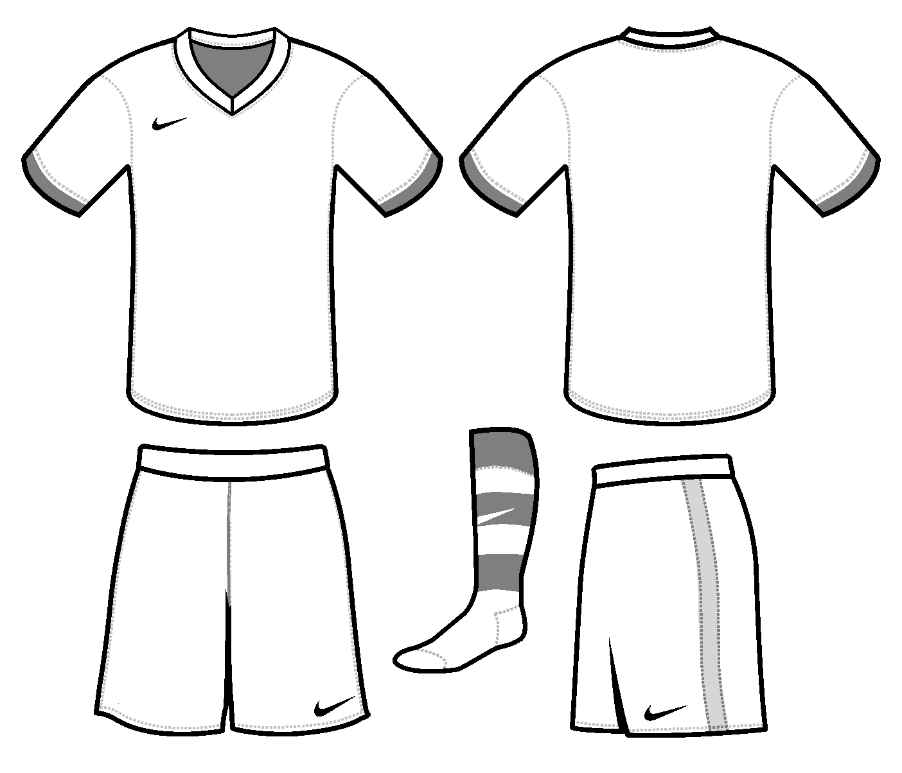

Explain the protest you are making and how you aim to get the message across using images and/or words and colours.

https://www.geographypods.com/qatar-world-cup-2022.html

