World Cup 2022 – What has caused these changes to Qatar?
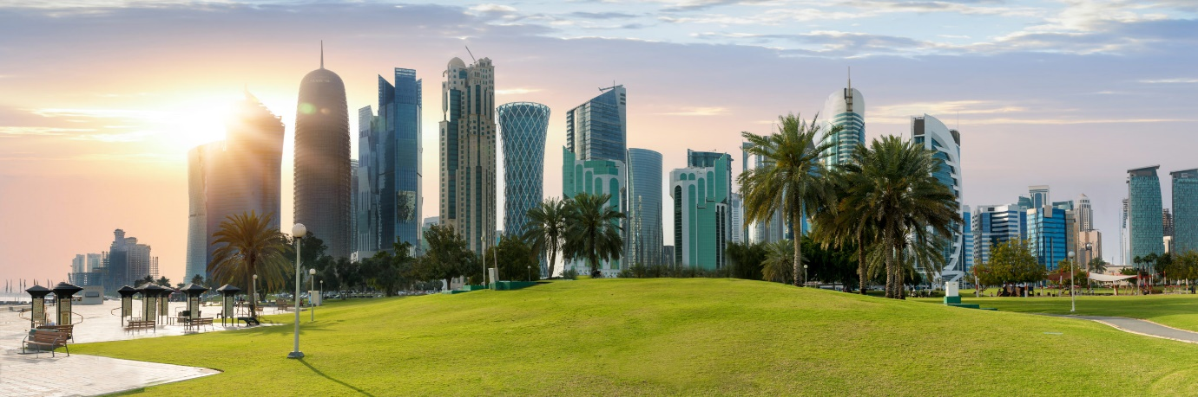

Watch the embedded video on geographypods. Starting at 0:45, make a note of the answer to the following:
Population of Qatar
Where do most people live?
What is the % makeup of the population of Qatar?
What is the national language?
What other language is spoken?
What is the main religion?
How do the Qatari’s remember their traditions?
Describe the traditional attire (clothes) of men and women in Qatar.
What are the rules on public shows of affection in Qatar?

What are the rules on dress sense in Qatar?

What are the rules on drinking of alcohol in Qatar?

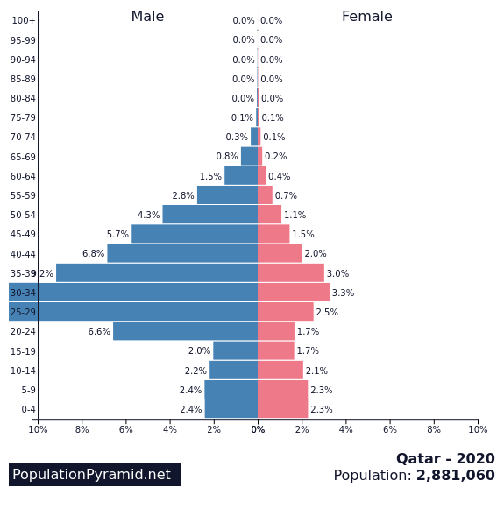

The population of a country can be shown in a model called and age/sex structure or a population pyramid. This shows the % of the population of different age groups for males (blue) and females (red) in a country. It is basically two bar charts stuck side-by-side.

In the first task, you heard about the population of Qatar. The population pyramid for Qatar is very strange. If you want to compare it to a more ‘normal’ one, check out France.

What is causing the Qatar pyramid to be so unbalanced? Can you think of any reasons why this might be, and how this could link into the rapid development of Qatar over recent years?
Clue?

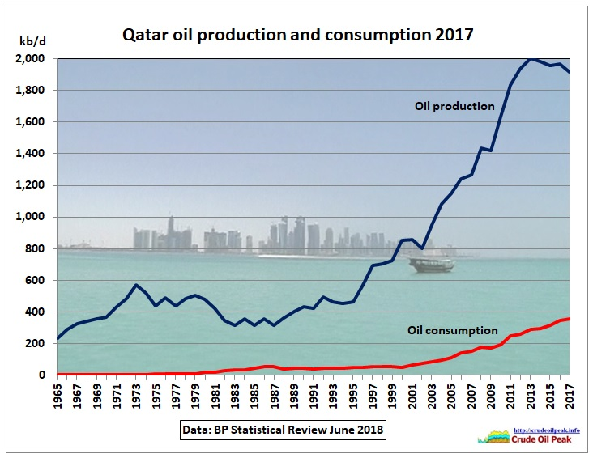

Using the graph above that shows oil production (blue line) and this animation from Gapminder, explain how oil has enabled Qatar to develop their country so fast over the last 50 years.

