Walls Around Our School – Brief Fieldwork

Using the embedded Google Map of our school site and a marker pen, highlight the barrier that separates our school from the outside world.

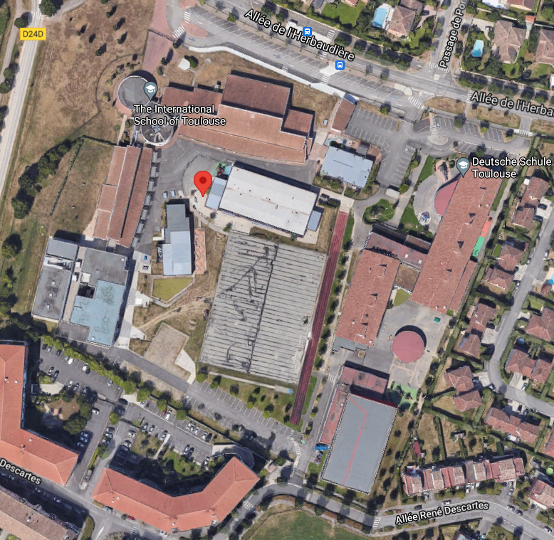

On the map above, you will see two stars. Your teacher will take you to both locations and you will need to bring this worksheet with something to learn on.
Star 1 – main gate in front of secondary reception
Star 2 – fence behind EC7

Bio Polar Analysis - In front of Secondary Reception
Barrier Characteristics | Very poor | Poor | Quite poor | No feelings | Quite good | Good | Very good | Total
 | -3 | -2 | -1 | 0 | +1 | +2 | +3
Height
Condition
Well made
Long lasting
Visual deterrent

Total:

Notes on this site. Open, exposed, hidden, visible, close to road, private housing etc.

On a scale of 1 (simple) to 10 (impossible), how easy would it be to cross this barrier and get in to / out of school?
1 | 2 | 3 | 4 | 5 | 6 | 7 | 8 | 9 | 10

Bio Polar Analysis - Behind EC7
Barrier Characteristics | Very poor | Poor | Quite poor | No feelings | Quite good | Good | Very good | Total
 | -3 | -2 | -1 | 0 | +1 | +2 | +3
Height
Condition
Well made
Long lasting
Visual deterrent

Total:
Notes on this site. Open, exposed, hidden, visible, close to road, private housing etc.

On a scale of 1 (simple) to 10 (impossible), how easy would it be to cross this barrier and get in to / out of school?
1 | 2 | 3 | 4 | 5 | 6 | 7 | 8 | 9 | 10

Now, thinking about both sites, is there anything else that is being used to stop people from entering the site / leaving the site when they should not be? How does this work?

