Grade 6 Geography – Good & Bad Connections
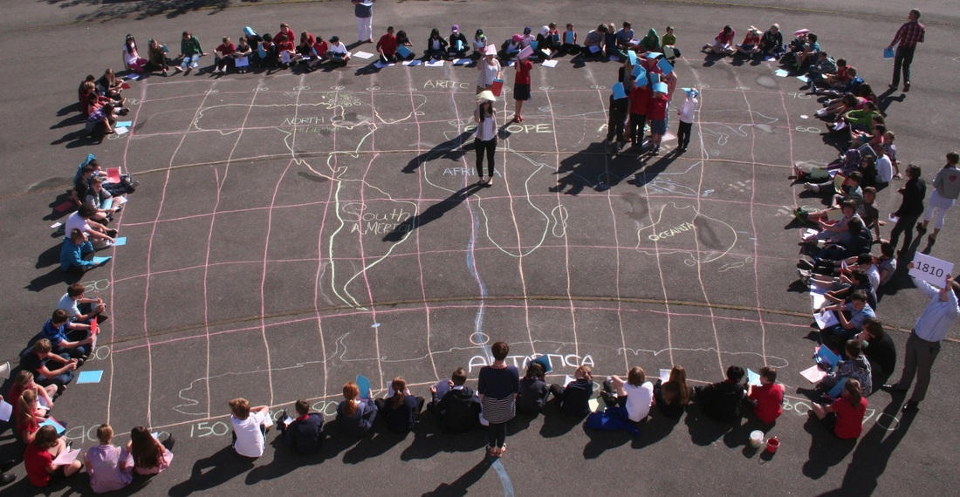

Task 1 – Which connections are the most important to you and why?

Task 2 – Which connections didn’t even exist 20 years ago? Which one of these connections couldn’t you live without in 2017.

Task 3 – Describe three new connections that may happen in 20 years’ time.

Task 4 – Name some examples of when connections can be bad. Can you find a recent story about it? (e.g. online bulling by Facebook)

Task 5 – Study the three images beneath. What two things are happening in each of the photos below?

