Qatar – Mind Map Activity
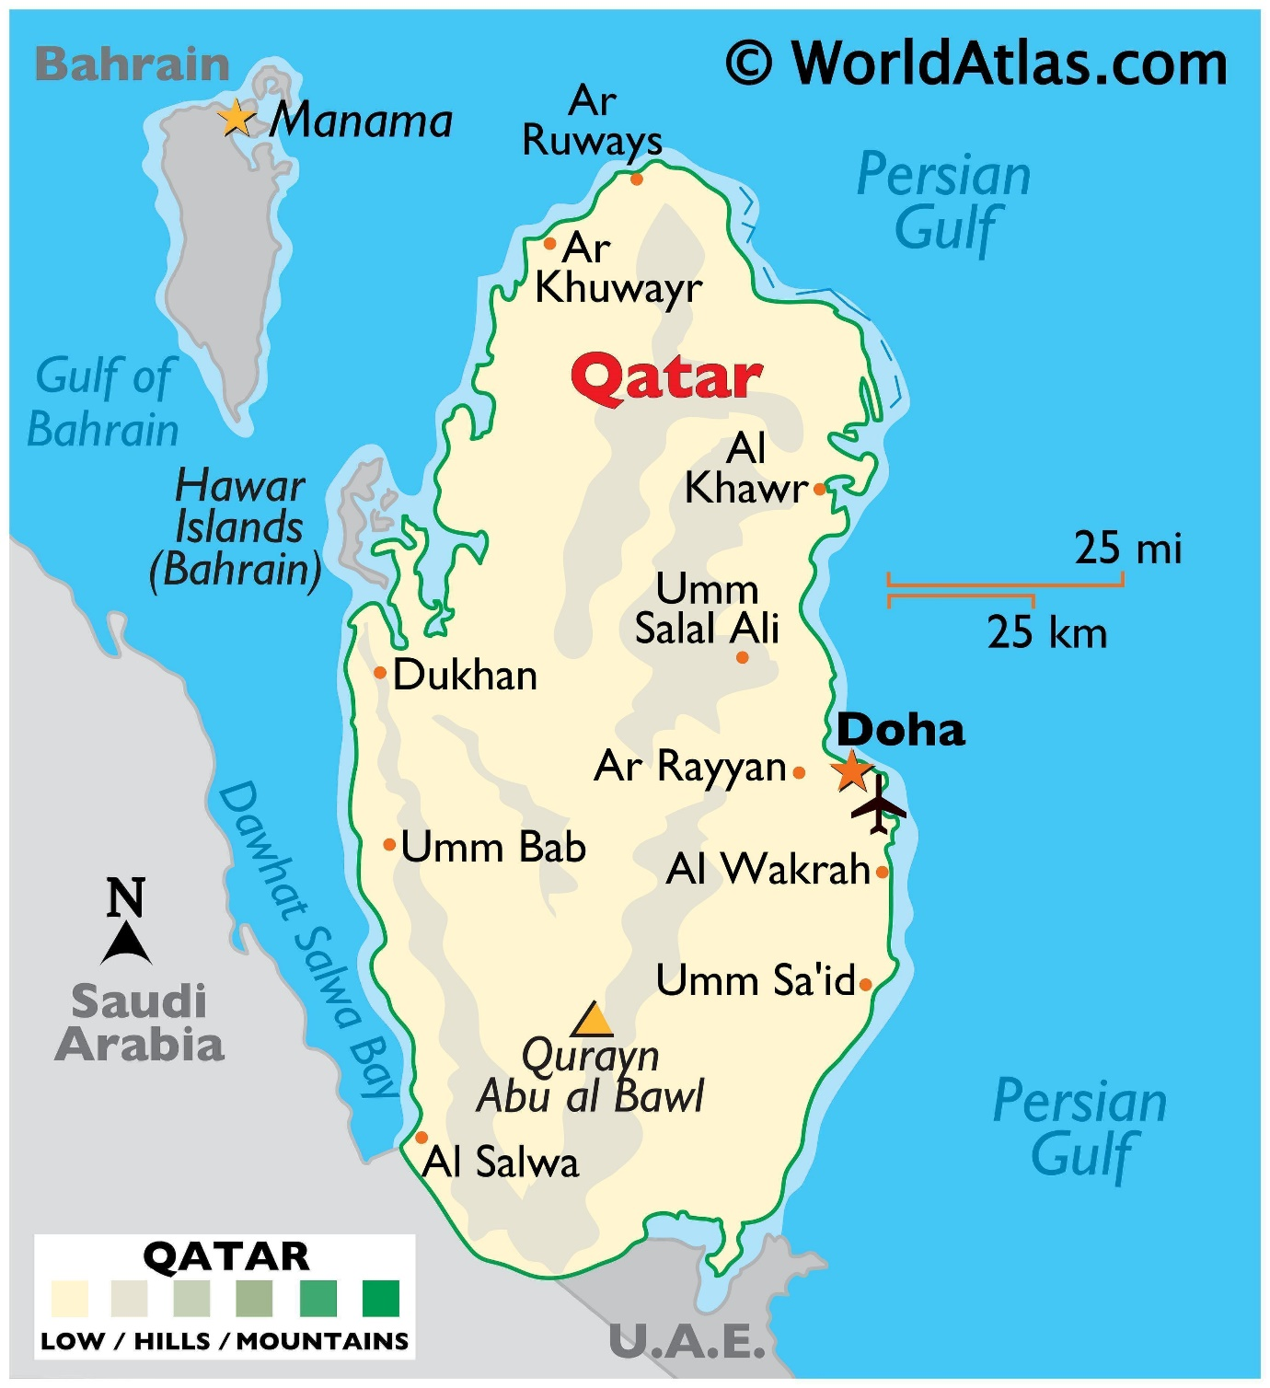

You will work in teams for this activity. Each team member will take it in turns to come up to a table and have up to one minute to stare at the map above and take in as much information as possible. You must then return to your table and transfer what you can remember on to the blank map of Qatar.

Qatar Mind Map Activity
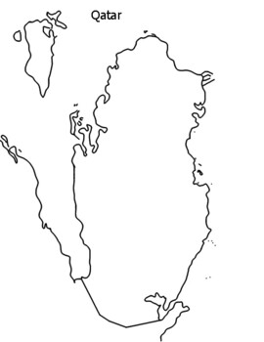
Name of team:

