|  |
| --- |
| **IGCSE Geography - What is my place in the world population? How long will I live?** |

My lovely selfie!

I am the _______________ person alive on the planet. This means that I am older than ____% of the world's population and older than ___% of all people in _________

**Imagine you lived today in a different country and with the life expectancy from a different time - how long could you expect to live? – Home life expectancy today ______ in 1988 ______**

A country where I would live to an older age than my home country

Where? ______________ What Age 1988? ____ What Age 2018?___

A country where I would live to a lesser age than my home country

Where? ______________ What Age 1988? ____ What Age 2018?___

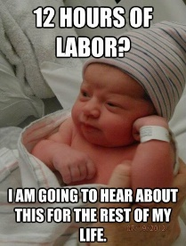

Global Pop:

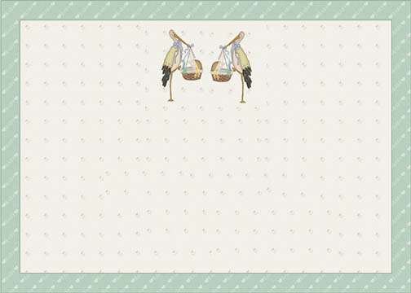

Your next milestone is ___________ then you’ll be ___________ billionth person to be alive in the world.

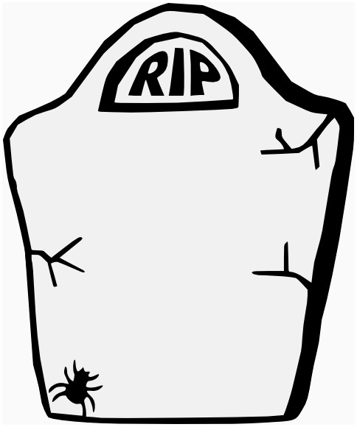

Date & Place of Birth

World Citizen Age:

______________ Age:

_____ Citizen

World Citizen

My top 5 shared birthday countries:

Did you know that you share a birthday with about ________ people around the world and that approximately _________ people were born in the same hour?