Grade 8 Geography – Ecosystems & Biomes
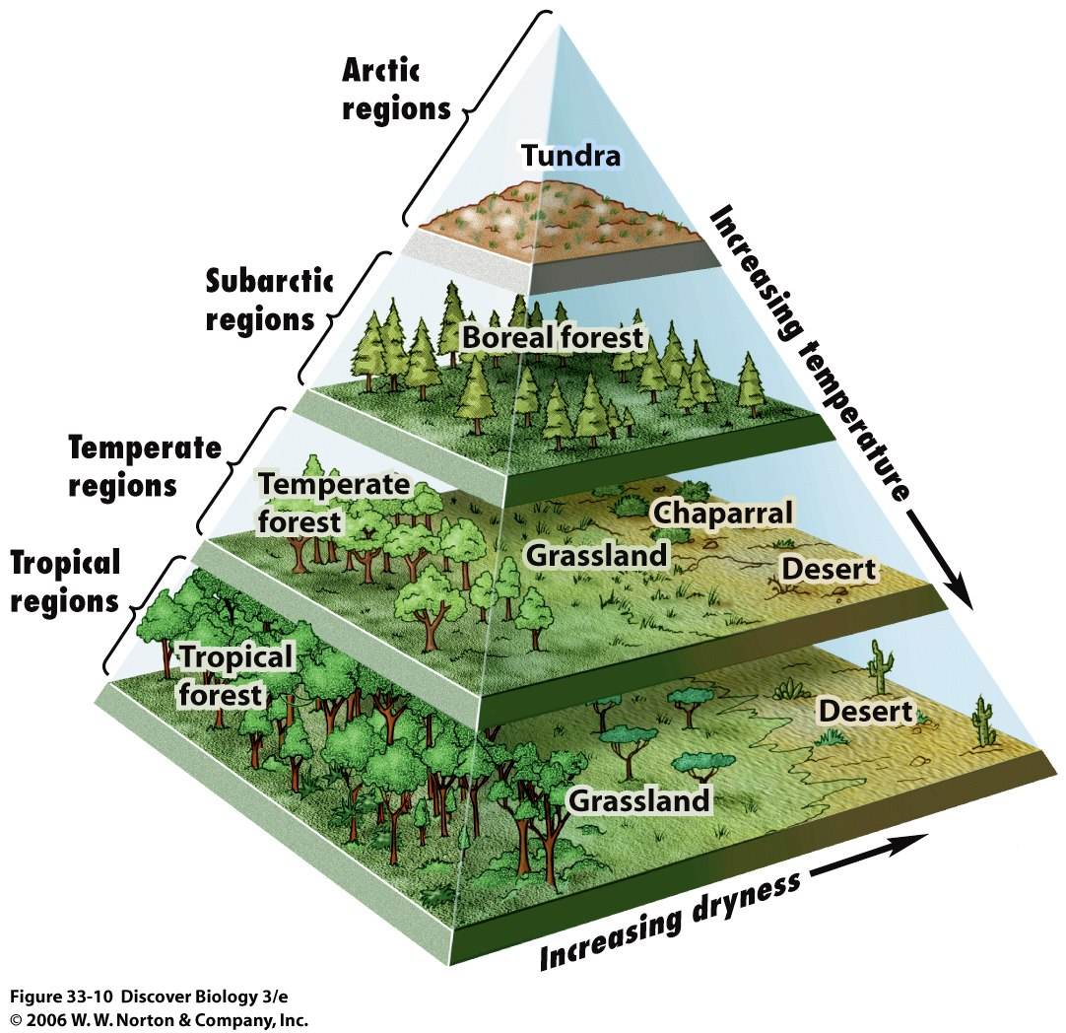
What is an ecosystem?

What is a biome?

According to the diagram above, what is the ideal relationship for plant life the thrive?

