**My Connections !**

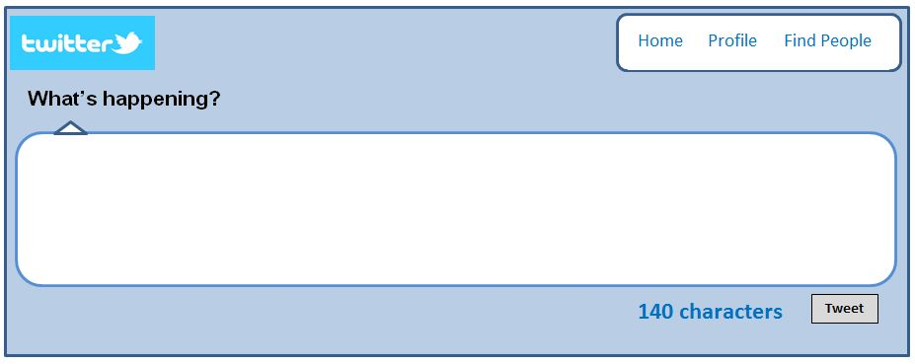

I am connected to ______________ on my right because

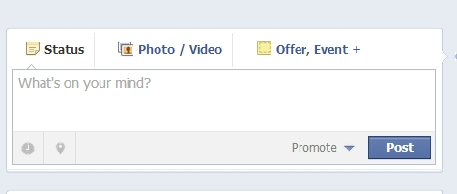

I am connected to _________________on my left because

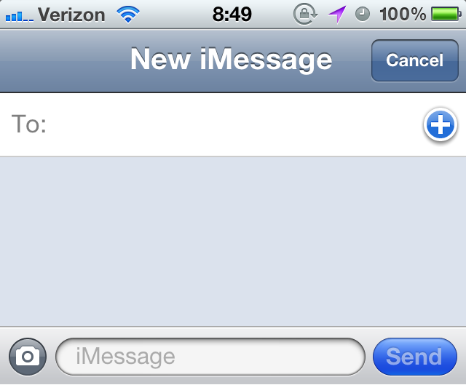

**My unusual connection to someone else is ….**

**Mr Podbury & Ms Orchard**