G7 – Ten Everest Adjectives!

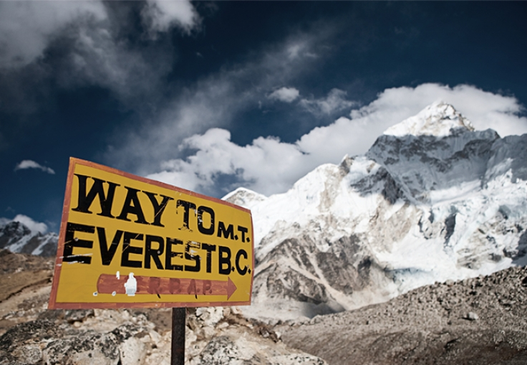

G7 – What happened on Everest in 1953?
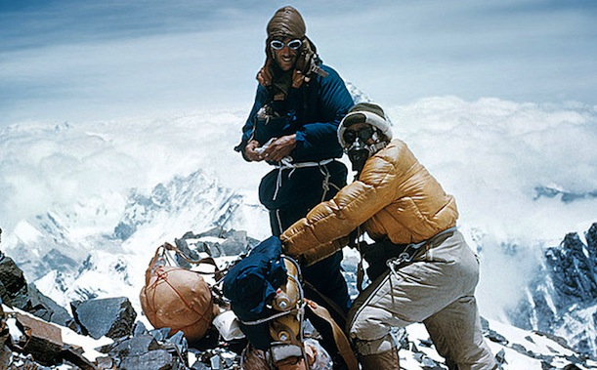

Person 1 - Factfile | Person 2 - Factfile

