G8 – Global Biomes – Transect
Name of Ecosystem | Picture of landscape | e.g. of vegetation and animals | Description of climate including data. | Three items for a survival kit.
1 | 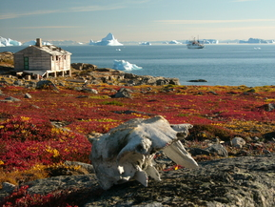
2 | 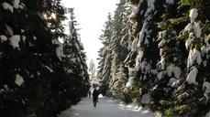
3 | 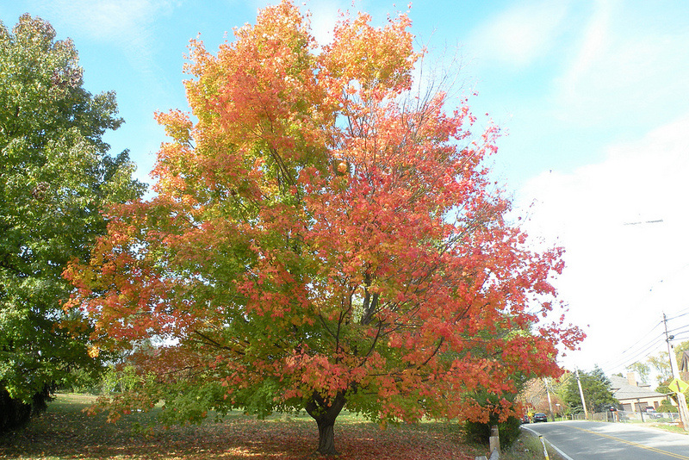
4 | 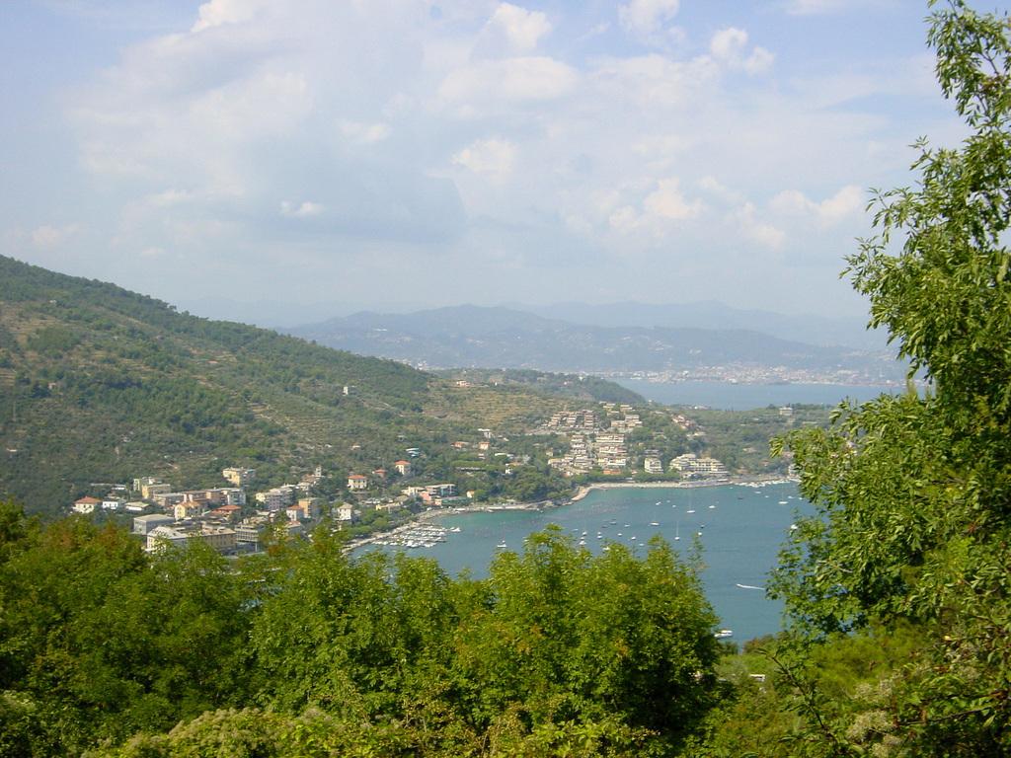
5 | 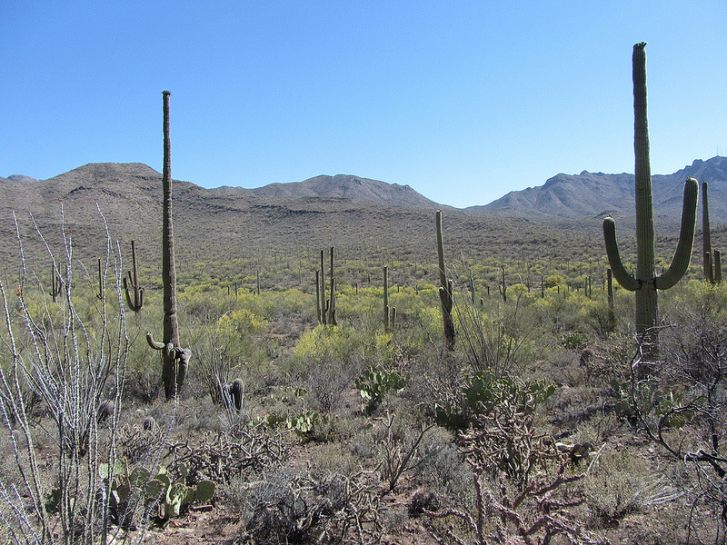
6 | 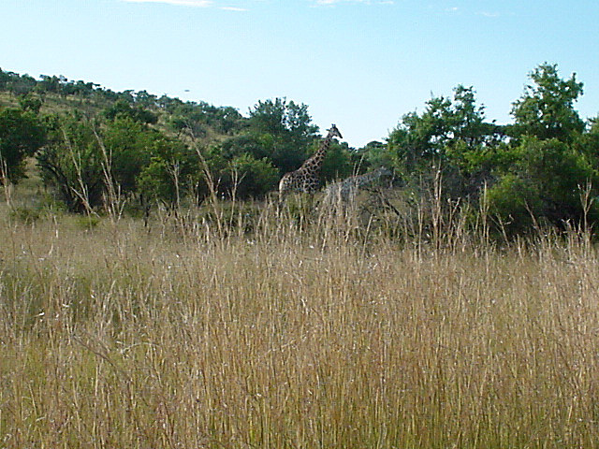
7 | 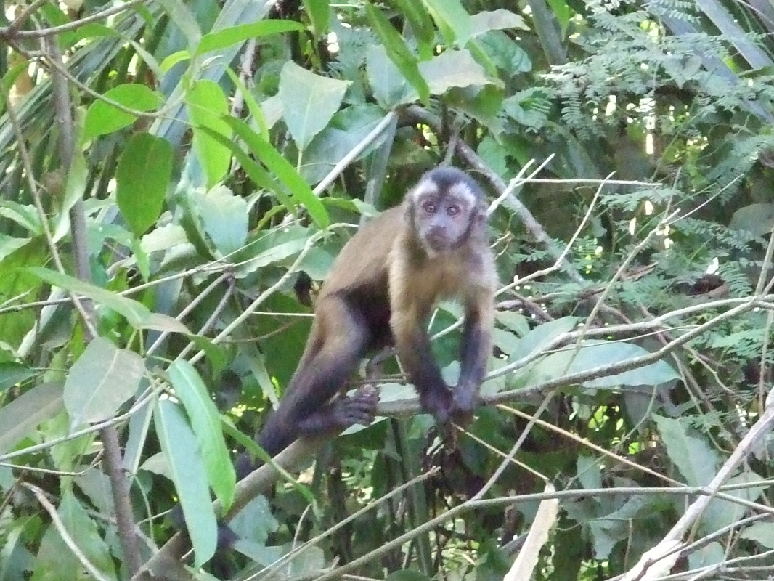

Personal Geography – How many of the biomes have I been too? Include when and where data below.

Map of major world ecosystems / biomes

Ecosystem Name | Country 1 Example & label on the map | Country 2 Example & label on the map
Tundra
Coniferous Forest / Taiga
Deciduous
Méditerranéen or Chaparral
Hot Desert
Savanna & Grasslands
Tropical Rainforest
Where is Toulouse on your map? Label the location.

In which biomes do we live? Which other biomes have you lived in?

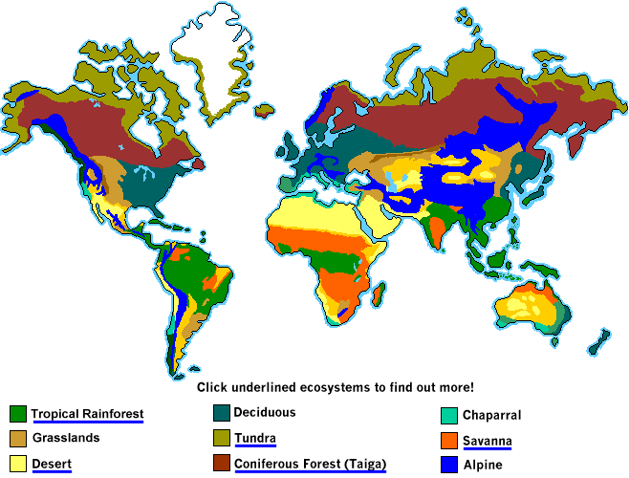
What happens when you drive from Toulouse to Montpellier?

