Key Stakeholders – New Shopping Centre – Val Tolosa

I am Adeline - a town planner who works for Plaisance du Touch local council.
This is currently empty land that is not being used for farming or the construction of houses. The trees were cut down a long time ago and the area looks quite untidy. People fly tip waste regularly on the site and it costs a lot to clean it up. Building a shopping centre would improve the overall look of the area and provide jobs and income for over 2000 local people.

Adeline - Town Planner
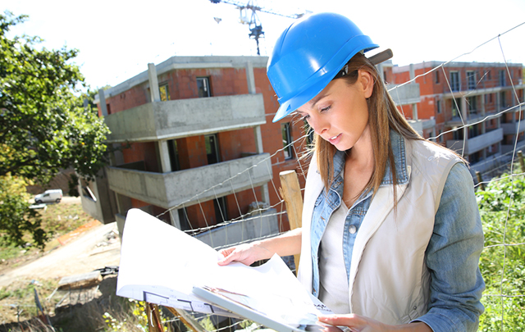

Key Stakeholders – New Shopping Centre – Val Tolosa
I am Gaelle, an environmentalist.
This is Greenbelt land. This means that it has never been built on before and if it is built on, it will be lost forever. The area has been left wild for years and so there is lots of wildlife in the area. There are many species of plants, insects and animals that rely on the area for their habitat including a family of buzzards. These are protected species and should not be destroyed by the new shopping centre. Toulouse is growing and growing and this is yet another example of us losing Greenbelt Land and concreting over a natural environment forever

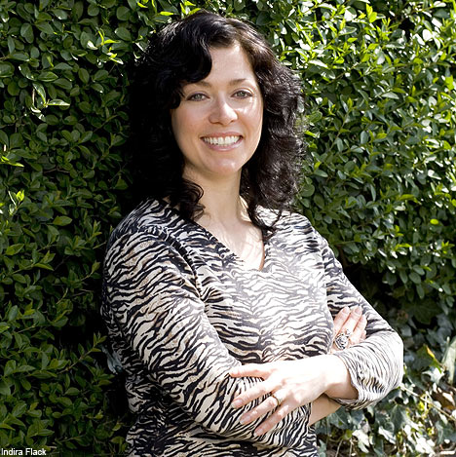

Gaelle - Environmentalist

Key Stakeholders – New Shopping Centre – Val Tolosa
I am Jose, a resident of Le Salvetat near the planned development.
Traffic around Pibrac & Le Salvetat and west of Toulouse is already a nightmare especially in the rush hour in the morning (7am – 9am) and evening (4pm-7pm). This shopping centre will attract all the people who work there (2000 people) plus all of the shoppers too. Imagine at Christmas and at weekends how busy and dangerous the roads are going to be. Our roads are not built for this volume of traffic. This is the last thing that we need

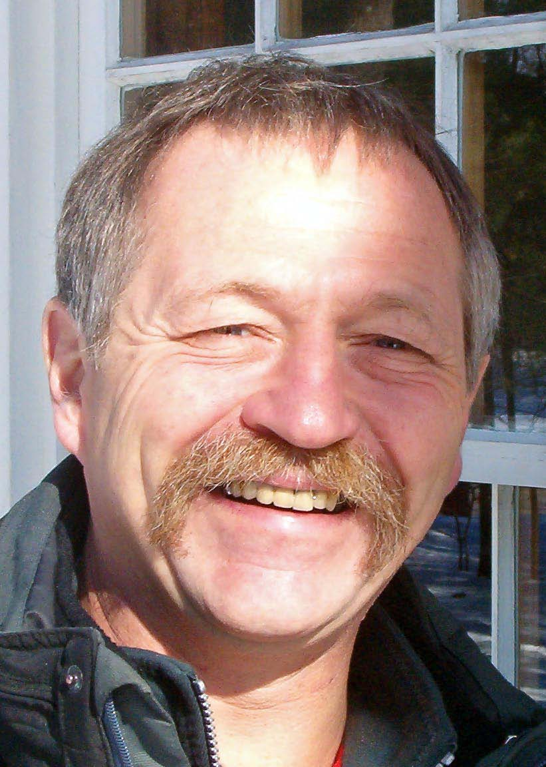

Jose - Local Resident

Key Stakeholders – New Shopping Centre – Val Tolosa

I am Carine, an unemployed person living in Pibrac
You do know that there is an economic recession at the moment? I used to work in the centre of Toulouse in Virgin Megastore until it closed down in 2011. Since then, I have been looking everywhere for a job but with no luck. Travelling into Toulouse would cost me money on the train but I could get a job in a shop in the new shopping centre and could cycle to work if they built a cycle path. I would then have a job and could afford to buy my own apartment in Pibrac or Colomiers.

Carine - Unemployed

Key Stakeholders – New Shopping Centre – Val Tolosa

I am Paul, a Year 10 student living close to bus routes in Plaisance du Touch. I have a part time job working and earn about €40 per week.
Public transport into Toulouse from Plaisance takes ages and is not very regular. I’m not old enough to buy a scooter yet and so I would love to have a place to go nearby where I can shop, eat and watch a film. Loads of my friends are in support of this too and it would also give us a sheltered place to meet and catch up with each other instead of hanging around in the bus stop in the town centre.

Paul - Local Teenager

Key Stakeholders – New Shopping Centre – Val Tolosa

I am Nicolas, a restaurant owner in Pibrac town centre.
I pay an absolute fortune to rent out my shop in the centre of town. My business has already declined due to the food court in Blagnac Shopping Centre opening in 2008 and this might be the final nail in the coffin for business here. There is no way that I can compete with the prices of food and drink offered by the big restaurant chains like McDonalds, Quick and Sushi Bar. I employ two full time chefs and three serving staff as well as buying all my fresh food and produce from the local Pibrac market.

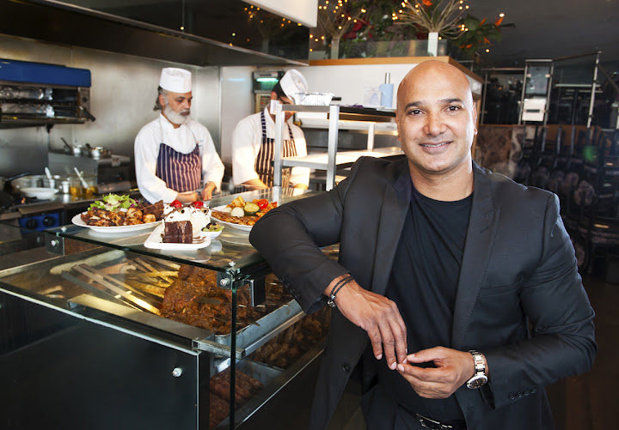

Nic - Restaurant
Owner

Key Stakeholders – New Shopping Centre – Val Tolosa

I am Sabine, a young parent with children living in Le Salvetat. I have a car.
Shopping in the centre of Toulouse is lovely but a bit of a nightmare. The price to park in the city centre is really expensive (nearly €4 per hour) and the traffic is really terrible too. It can take over an hour to drive in and out and is particularly bad on Saturdays as everyone goes shopping then as the shops are closed on Sundays in France. Having shops where I can buy clothes and food for my children nearby would be brilliant as well as the free parking. It would only take me 3 minutes to get there!

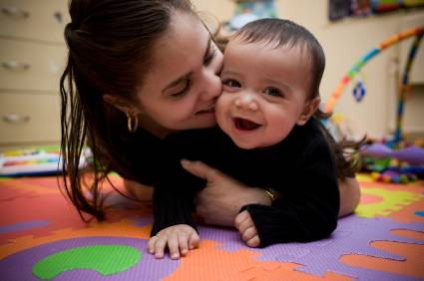

Local Family with Children

Key Stakeholders – New Shopping Centre – Val Tolosa

I am Tony, a retired vet without a car living in Pibrac. Val Tolosa is another shopping centre that I can’t get to. There is a bus that goes close by but carrying bags of shopping is not an option for me. I prefer shopping in the centre of Pibrac but gradually, all the shops are either closing down or moving elsewhere due to new supermarkets opening or new shopping centres being build. If they introduced a bus route or a courtesy bus to the shopping centre, that would be great for me and my friends.

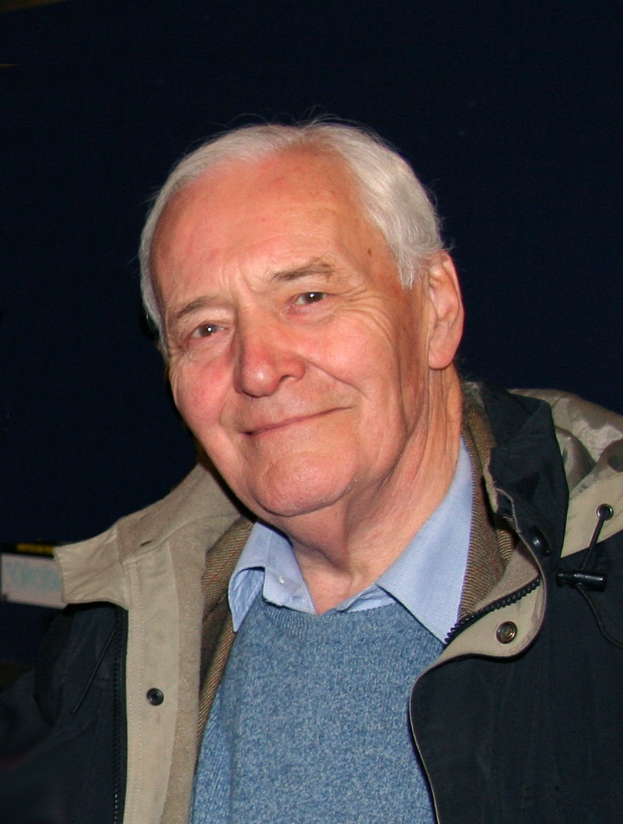

Tony - Older Person

Key Stakeholders – New Shopping Centre – Val Tolosa

I am Louis, the manager of Carrefour Supermarket in Pibrac. People like supermarkets because they can buy everything from bread to mountain bikes under the same roof. We buy our stock in bulk and so can offer lower prices than smaller, traditional food stores and grocers. People don’t want to have to go to ten different shops to get their weekly shopping when they can just go to one place instead. There is already a Carrefour Market store in Pibrac but we would close that and open a bigger one in the new Shopping Centre that would have better offers and employ more staff.

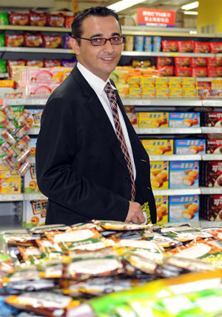

Louis - Carrefour Owner

Key Stakeholders – New Shopping Centre – Val Tolosa

My name is John and I am an Airbus worker who lives in Fonsorbes and commutes by car every day to Blagnac. During the school holidays, it only takes me 20 minutes to get into work but during term time and especially on Tuesdays & Thursdays it can take up to an hour to get in because of all the traffic. Can you imagine the extra traffic in the evenings going to and leaving Val Tolosa on the D82 & D24. These are countryside roads and are certainly not built for the numbers of traffic that we currently have, let alone the projected increase that will happened when the shopping centre opens. It is going to be a complete & utter nightmare.

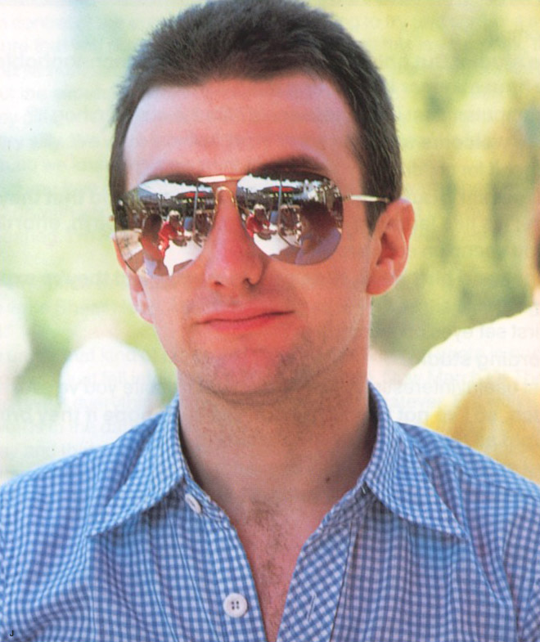

John – Airbus Worker

Key Stakeholders – New Shopping Centre – Val Tolosa

My name is Jean-Luc Moudenc and I am the mayor of Toulouse. Toulouse is France’s fourth biggest city (1. Paris, 2. Lyon, 3. Marseille, 4. Toulouse) but we are growing by nearly 20,000 extra people per year. People like living in Toulouse as it is close to the Pyrenees and the Mediterranean coast and the city itself is very beautiful. The aviation industry and in particularly Airbus is thriving and we can attract lots of people (students, workers) because of this. All these extra people need facilities and leisure activities to do and it ultimately creates more jobs and will help us to overtake Marseille to become the third biggest city in France.

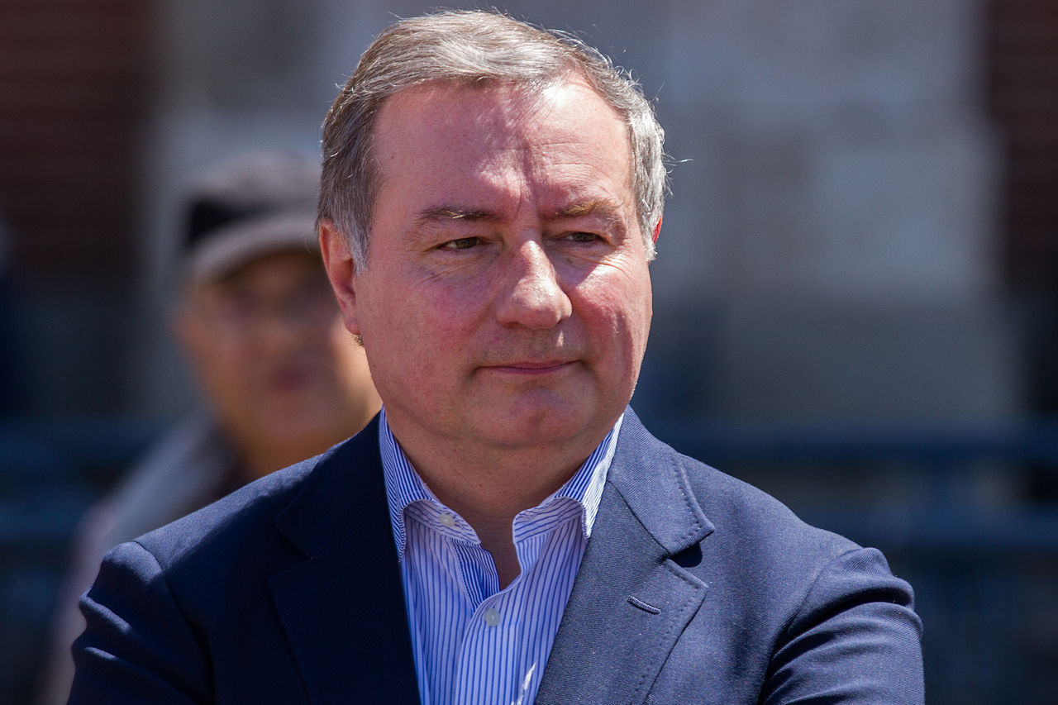

Jean Louc – Mayor Of Toulouse

Key Stakeholders – New Shopping Centre – Val Tolosa

My name is Patricia and I am the farmer that sold off all of the land to the Val Tolosa Development team. The farm originally used to grow crops on the fields and in recent years and with failing health, my father could no longer work the land and so eventually gave up, passing the farm on to me when he died last year. I tried to make the business work as a horse riding centre, but without success. Faced with huge tax d’habitation bills and no income, I reluctantly decided to sell all of my land and the family farm to the developers. I know my neighbours don’t like it but what choice did I have?

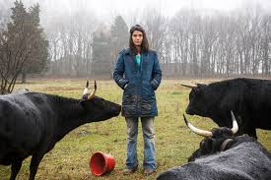

Patricia – Farmers Daughter

Key Stakeholders – New Shopping Centre – Val Tolosa

My name is Tim Cook and I am the CEO of Apple. We are always looking to expand our product base and exploit new markets. Although I’ve never been to Toulouse before, I know that it is a growing city where technology is at the forefront of innovation. It would seem to be logical that we invest in the flagship Apple store in the new Val Tolosa development. Nothing else like this exists and the closest store is currently in Barcelona. We believe that Toulouse wants an Apple store and that we can expand the Apple family and create 15 permanent jobs.

Tim – Apple CEO

