IGCSE Geography – Earthquake Case Study – Japan 2011
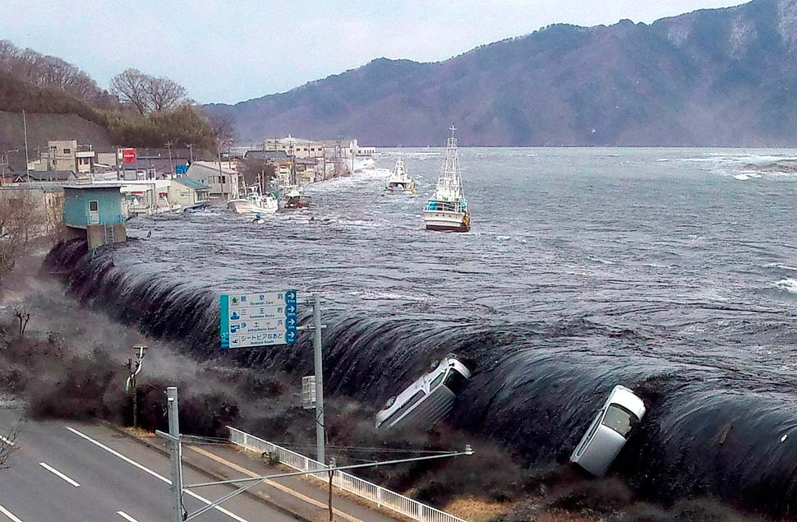
Step 1 - In the space below, sketch the plate boundary locations around Japan.
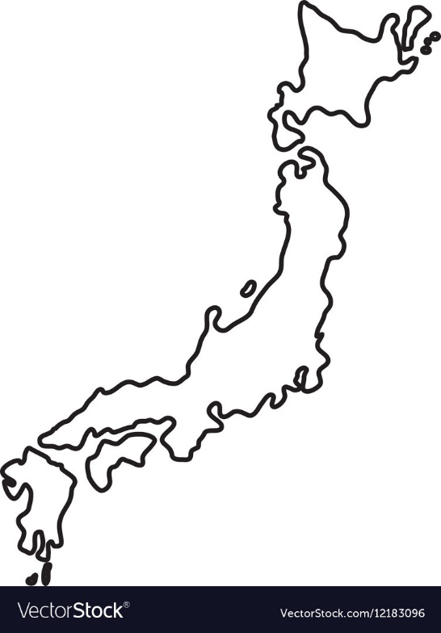

In the space below and using the link on geographypods, complete steps 2 – 3. The map is part complete; you need to draw the rest.

Step 4 – Complete the fact box in the space below.
Name of quake:

Date of quake:

Ranking in terms of strongest earthquakes ever (Wikipedia):

Amazing Facts:

- The earthquake shifted Earth on its axis of rotation by redistributing mass, like putting a dent in a spinning top. The temblor also shortened the length of a day by about a microsecond.

- The jolt moved Japan's main island of Honshu eastward by 2.4 meters.

- The tsunami broke icebergs off the Sulzberger Ice Shelf in Antarctica.

