IGCSE Geography - Introducing Migration
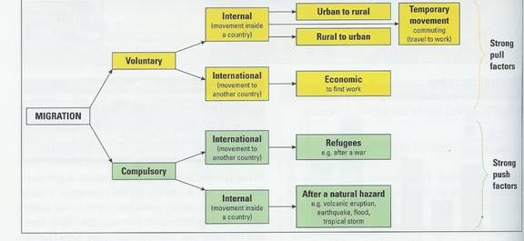

Q1. What is the difference between voluntary and compulsory (involuntary) migration?

Q2. What is the main reason why many voluntary migrants move internationally? Why might this be?

Q3. What is the main reason why many compulsory (involuntary) migrants move internationally? Can you think of any recent examples?

Q4. What does ‘rural to urban migration’ mean? Why might people do this? Can you think of an example?

Image | Voluntary or Involuntary | How do I know?
