IGCSE Geography – Global Energy – What’s the story?
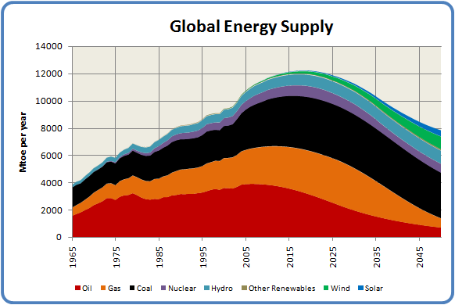

Task 1 – Complete the paragraph below by choosing the words from the box below.
As the world's population continues to _________ and as peoples level of development continues to grow, so does the demand for _________. In traditional less developed societies the main source of energy tends to be fuelwood. Fuelwood can be used for __________, cooking and even scaring away ______________ .

As countries begin to develop they can begin to afford to buy raw materials and to build power stations. Most commonly fossil fuels are burned because the _____________ exists and at the moment they are widely available.

However, as countries develop further their sources of energy may change again. They will probably still be heavily dependent on __________________, but will begin to use more ________________ energy and probably more nuclear. The reasons for the change include:

- Greater concern for the ___________________
- Rising __________ of fossil fuels
- The knowledge that fossil fuels are ___________
- Aim to reduce reliance on fossil fuel exporting countries
- Improvements in renewable technology
- The hope of developing and selling renewable technology
- Better technology and increased stability allowing ____________ development

There are always some exceptions to the rule. For example Costa Rica gets the majority of its power from renewable sources and countries like Lithuania and France get nearly all of theirs from nuclear.
fossil fuels, energy, nuclear, environment, renewable, heating, prices, finite, technology, grow, wild animals

Key Words for this unit of work

Non-renewable energy: Energy that can not be reproduced in the time that it takes to consume it e.g. coal.

Renewable energy: Energy that is naturally occurring and potentially infinite.

Fossil fuels: Any combustible organic matter that is made from the remains of former flora and fauna.

Raw material: Any unprocessed material.

Thanks to Greenfield Geography for text.

