IGCSE Geography - Planning for the Future - Age Sex Structures
Objective: To be able to effectively read and interpret population pyramids.
Starter: Study the most recent population pyramid for France and then describe why the French President wants to raise the retirement age by two years for French workers.

Task 1 - Watch the video and explain the features of the population pyramid for France. What does the term ‘spinning top’ refer to?

Task 2 - Have a play with this population pyramid site - check out your home country. Write a few sentences to explain what future population growth or decline is going to be like there. Take screen shots of the structures on the next page.

When I was born – Year:

When I will be about 50 – Year:

When I will be about 100 – Year:

Country with a high level of economic development - France
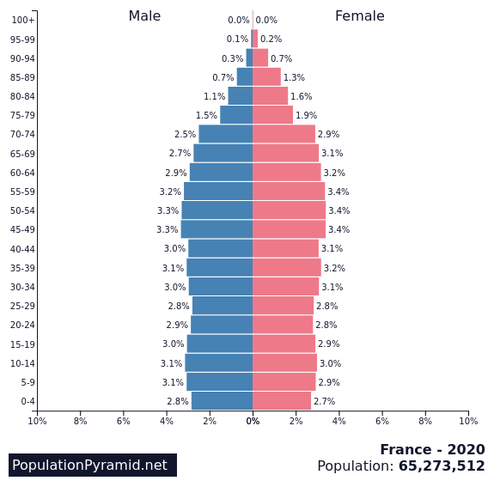

i. Choose France and the year 1950. Explain the indentations 25-39 years old and 5-19 years old.

ii. What was the population of France in 1950?

iii. What is the population of France now?

iv. Describe the structure of the pyramid for France this year.

v. What are the key population issues facing France today?

vi. What percentage of the population will be over the age of 60 years old in the year 2050?

vii. Is France becoming a country with a youthful or ageing population? Explain your answer.

Country with a low level of economic development – The Gambia
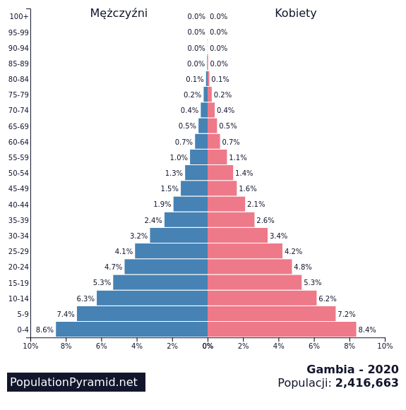
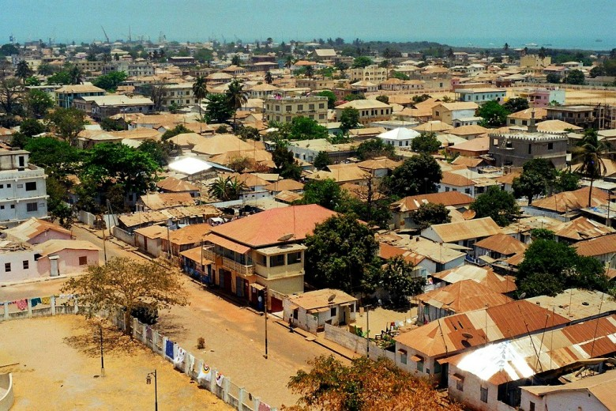

i Using the same tool, choose Gambia and the year 1950. Note the total population in 1950.

ii. What is the population of Gambia now?

iii. Approximately, how many times more is the population than in 1950?

iv. Describe the structure of the pyramid for Gambia this year

v. What are the key population issues facing Gambia today?

vi. How is the population structure of Gambia going to change by the year 2050?

vii. Is Gambia becoming a country with a youthful or ageing population? Explain your answer.

