**Introducing Zimbabwe – IB Geography**

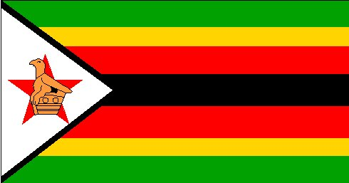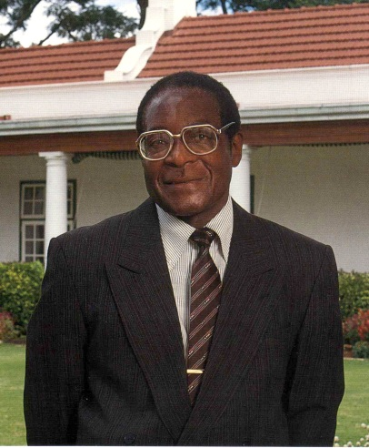

One unique fact:

Zimbabwe Fact Box

Mugabe Profile

Zimbabwe Map