Year 7 Geography - Tornadoes
Task 1 – Study the imagery carefully. You have 10 minutes, what will you do?

Task 2 - You have less than 5 minutes, where will you go?

Task 4 - Then the tornado strikes!
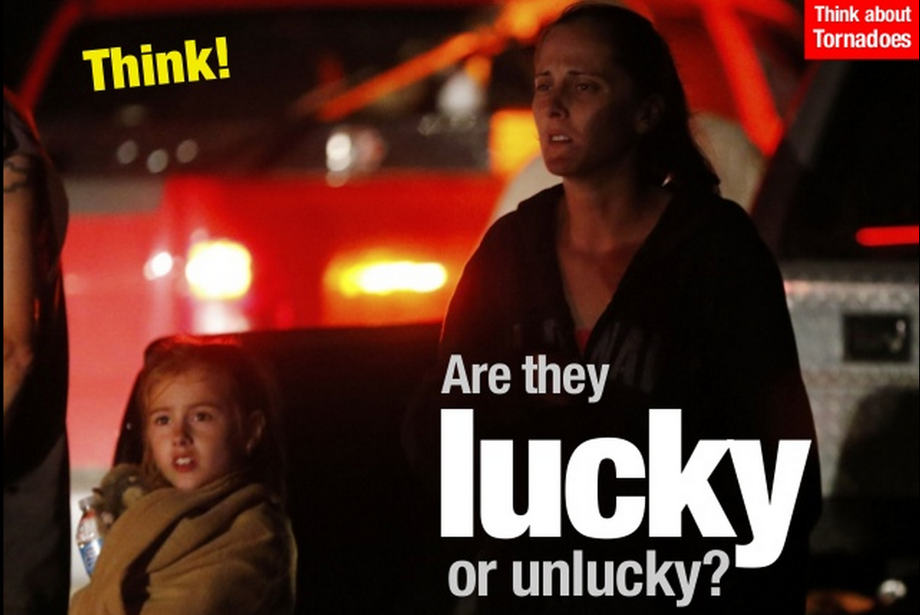

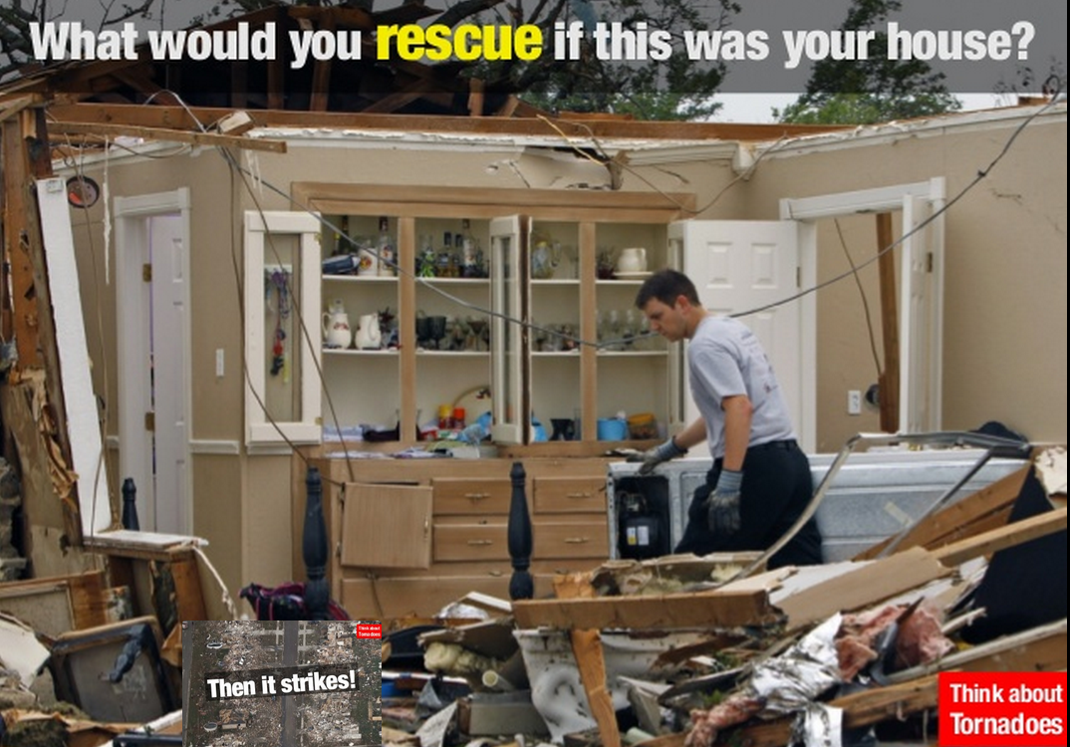

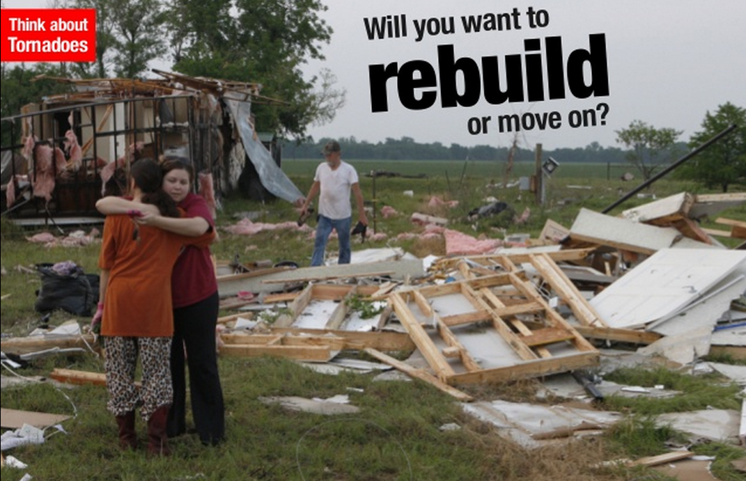

Task 5 - Write down your feelings about tornadoes using at least 10 different adjectives. Underline each adjective.

