G7 Geography – Who are the Sherpa?
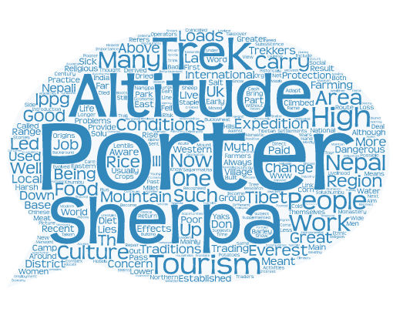

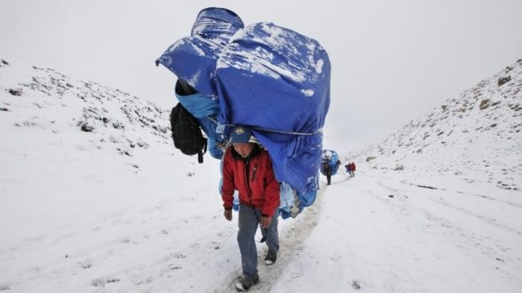
What is the most diffficult thing that you have EVER done?
Task – Using the Wordle above and the image to the right hand side, write down some things that the Sherpa do on Everest.

