IGCSE Geography – Internal Migration Brazil – Stay or Go?
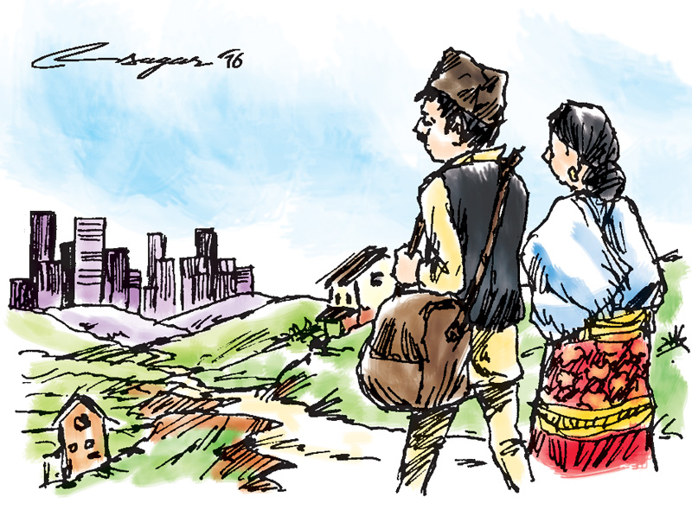
Image Source: Himalayan Times
This scenario is about Margarita and her family who live in the north east of Brazil. The family is currently split apart with her husband living in Rocinha, a large favela in Rio de Janeiro.

Task 1 - Using the cards, please complete a person profile of Margarita by annotating her family situation around the photo beneath. (these are the yellow cards).
Margarita lives with her grandparents, parents and three daughters in Northern Brazil.

Task 2 – Using the information on the cards, list the push and pull factors in the table beneath that apply to Margarita and her decision on whether or not to move to Rio from the north east.
Push from the rural north east of Brazil | Pull to urban area of Rio de Janeiro
The weather is extremely hot, with extensive dry periods in the North East. | Margarita would receive higher wages if she moved to Rio and could get a job.

Task 3 – List below the reasons for Margarita to stay

Task 4 – Stay or Go? List below the top three reasons for Margarita to stay and the top three reasons for her to go. You decide!
Stay | Go
1 | 1
2 | 2
3 | 3

Task 5 - Should Margarita stay in NE Brazil or move to Rio de Janeiro. You must have reasons for the answer that you give.
This is a really difficult decision as life in both places is not really ideal. Life in the NE of Brazil is tough because …

Life in Rio is also difficult because…..

But, in the end my decision is ….

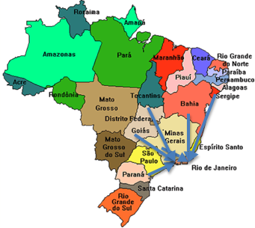
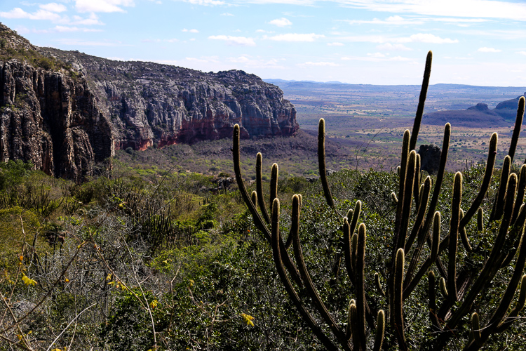

Task 6 - Can you think what problems might be caused if lots of people from rural areas in Brazil decided to move to cities such as Rio de Janeiro. How would this affect both the city and the rural area that the people are moving from?

Houses:

Food:

Crime:
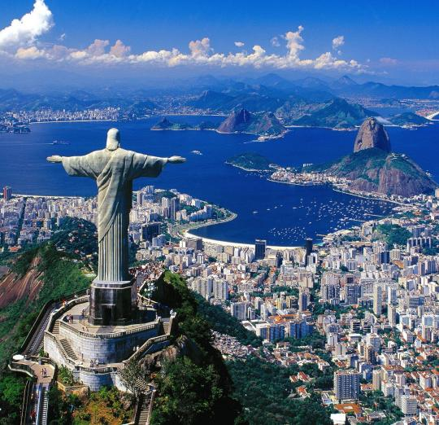

Task 6 continued

Task 7 – Exam Corner
(c) Choose an example of rural to urban migration in a country that you have studied.
Name the areas between which people moved and explain why many people migrated. You
should refer both to pull and to push factors. [7]

