IGCSE Geography - Economic Development & the Natural Environment
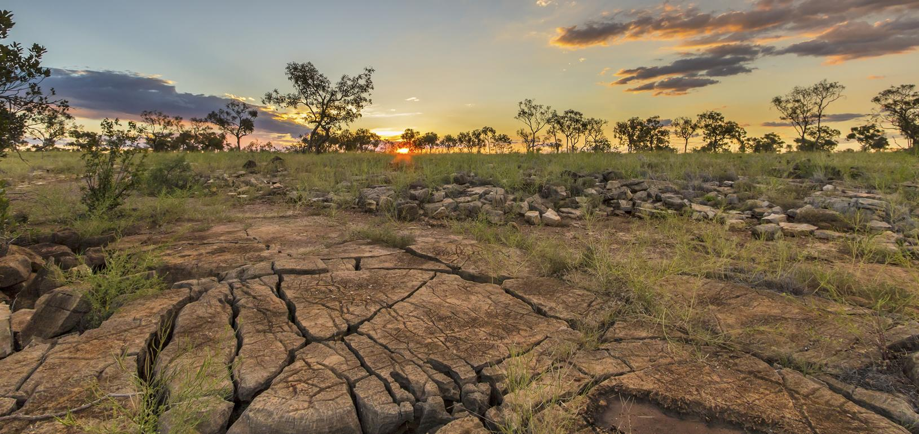

Part 1 – ​Watch the two videos on geographypods which show the causes and solutions to two huge environmental problems that are linked to economic development.
Issue | Causes | Solutions
Traditional Farming | When farmers turn their soil over at the start of the season to plant new crops, it is not bound together by the roots and so can be blown away or washed away by wind. This happened in the USA in the 1800’s (Dust Bowl) and cost the worst environmental disaster in the history of the USA. This is called soil degradation. | Conservation Agriculture – farmers don’t turn over the soil as often. They leave some crops in the fields at the end of the harvest to stop the soil from being washed or blown away.
Desertification | This can happen because trees are cut down by people in LEDCs looking for firewood, or when too many animals graze on the land and they eat all the vegetation. This leads to the soil being exposed and being washed or blown away (like the example above too). This leaves the land completely infertile. | In Africa, they are in the middle of planting ‘The Great Green Wall’ – so a forest of trees stretching along the southern edge of the Sahara to stop the desert from expanding.  Planting trees (agroforestry) helps to keep the soil together and adds natural nutrients to the soil when leaves fall and decompose.

Part 2 – ​Watch the next two videos on geographypods. They contain information about the impacts of economic development on our changing climate (climate emergency) as well as air pollution.
Issue | Causes | Solutions
The enhanced greenhouse effect. | The Enhanced Greenhouse Effect is when we add too many greenhouse gasses to our atmosphere (methane, CO2 etc.) by burning fossil fuels, and this ‘thickens’ the atmosphere and traps more heat, that should ordinarily be able to leave back into Space. This causes a warming of our planet and is leading to more severe weather, rising sea levels and increases respiratory illnesses for people. | Moving away from our addiction to fossil fuels and towards renewable energy, including wind power, HEP, solar energy. Think about your previous work on energy!  We can also change to Electric Cars (but you still need to know where the electricity that charges your car comes from!!) and changing diets, particularly regarding meat consumption (cows burps!).
Air pollution | Air pollution refers to harmful particles in the air released through natural (volcanoes, wildfires) or human processes (energy, agriculture). When we burn fossil fuels, we release CO2, Carbon Monoxide, Methane etc. Think about your congestion in Toulouse case study (settlement) and the issues caused by too many cars on the roads.  Too many pollutants in the atmosphere can lead to smog (mixture of fog and smoke). Smog can have a lot of sulphur in it, caused by burning coal. You will see the result of this in the activity coming up. | We can limit toxic pollutants by reducing our consumption of fossil fuels and transferring to renewable clean energy (HEP, solar, Wind etc). Links to your previous work.  Electric cars / future electric planes etc. Think about Airbus and their project to get jets to run on algae, instead of kerosine.

Define ‘resource conservation’.
Resource conservation means reduction of the amounts of solid waste that are generated, reduction of overall resource consumption and utilization of recovered resources.

Watch the Economist on geographypods and take notes on the causes and effects of fast fashion industry.
Causes | Effects

Watch the second video (Patagonia) and outline how the company are trying to be more focused on resource conservation and environmental protection.

