IGCSE Geography - Economic Development & the Natural Environment
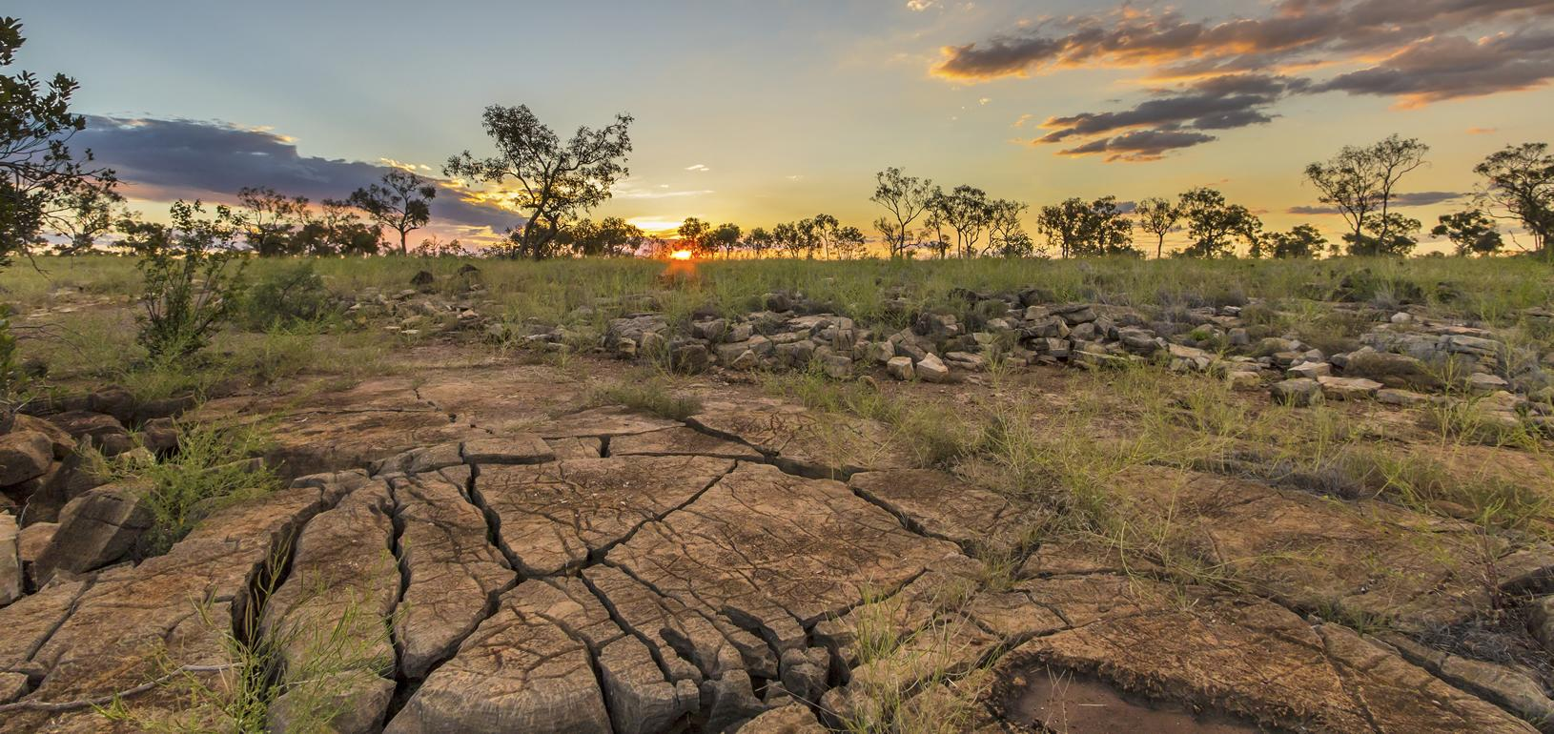

Part 1 – ​Watch the two videos on geographypods which show the causes and solutions to two huge environmental problems that are linked to economic development.
Issue | Causes | Solutions
Traditional Farming

Desertification

Part 2 – ​Watch the next two videos on geographypods. They contain information about the impacts of economic development on our changing climate (climate emergency) as well as air pollution.
Issue | Causes | Solutions
The enhanced greenhouse effect.

Air pollution

Define ‘resource conservation’.

Watch the Economist on geographypods and take notes on the causes and effects of fast fashion industry.
Causes | Effects

Watch the second video (Patagonia) and outline how the company are trying to be more focused on resource conservation and environmental protection.

