IGCSE Geography – Improving Life in Urban Areas in Rio De Janeiro (Brazil – MIC)

Scheme 1 – Self Help Housing – Link to your diagram sheet. |  |  | Scheme 2 -Barra da Tijuca – Building a better life for wealthy residents
Brief description of scheme  Self-help schemes - Rocinha, Favela Bairro Project. They have set up self-help schemes. This is when the local authority provide local residents with the materials needs to construct permanent accommodation. This includes breeze blocks and cement. The local residents provide the labour. The money saved can be spent on providing basic amenities such as electricity and water. Today, almost all the houses in Rocinha are made from concrete and brick. Some buildings are three and four stories tall and almost all houses have basic sanitation, plumbing, and electricity. Compared to simple shanty towns or slums, Rocinha has a better developed infrastructure and hundreds of businesses such as banks, drug stores, bus lines, cable television, including locally based channel TV ROC, WIFI. Business is booming in the favela. | 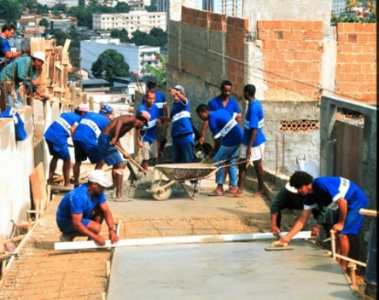 |  | Brief description of scheme  Wealthy residents of Rio looked for a safer place to live with more space when the CBD became too congested and crime rates were problematic. Nearest flat land 20 KM along coast that was originally beach and swamp land. In, 1970 4 a 4-lane motorway cut through mountains and on stilts over sea linking Rio to Barra and making the area accessible to commuters. This moving out of the city is referred to in Geography as counter urbanisation (opposite of urbanisation). In the year 2015, this new town of Barra had population of 650,000 fed by the continuous process of counter urbanisation. Barra can be considered to be a self-contained city and has a strip containing 5 KM of shops, schools’ hospitals, offices, entertainment and various developments that were put in place for the 2016 Olympic Games. Spacious, luxurious accommodation. 3/4 of accommodation is in high-rise apartments, protected by security guards. | 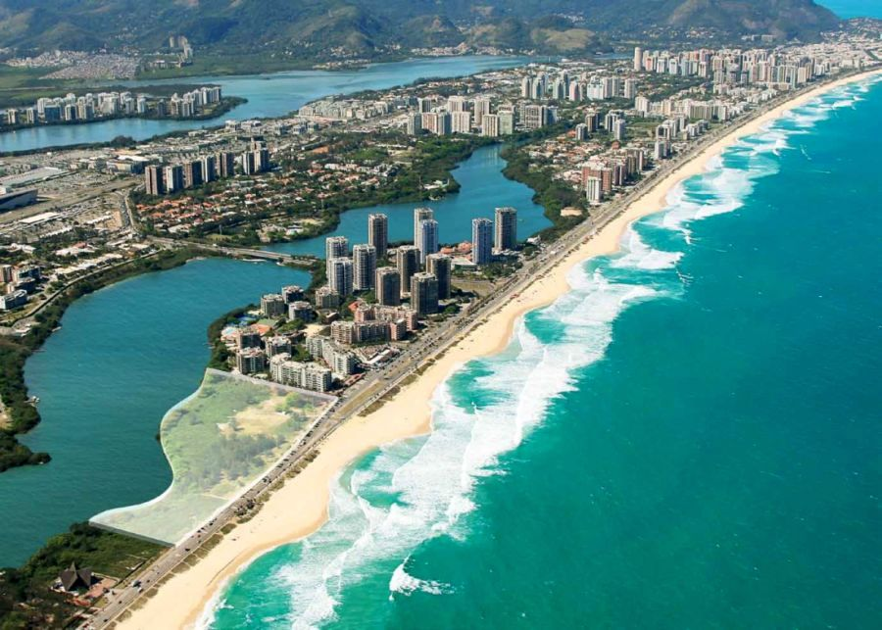
Which problem does it help to solve? | How does it help to solve this problem? | How well will it work? (Evaluation) | Which problem does it help to solve? | How does it help to solve this problem? | How well will it work? (Evaluation)
Self help projects help to solve issues caused by sub standard illegal settlements such as fires, overcrowding, illness caused by poor sanitation and building collapse.  It offers recognition by the government that the settlers have a right to be there and the process of self-help also teaches residents the skills of building, plumbing etc which can be used to forge a career in the future helping with other construction projects | The aim of the scheme is to empower people and improve health and wealth in the favela.  Improved sanitation leads to better health and lower death rates and child mortality rates  Skills can be transferrable and workers can enter the formal sector where they can start to pay social charges and taxes benefiting the government and encouraging the multiplier effect. | These give people the tools and training to improve their homes but will require a significant investment by the Brazilian government. However, low-interest loans may be used to help people fund these changes and people may be given legal ownership of the land.  Currently, Brazil is experiencing a severe economic slowdown caused primarily by excessive spending on the Olympics, World Cup as well as political unrest and high unemployment.
Scheme 3 - |  |  | Scheme 4 -
Brief description of scheme | 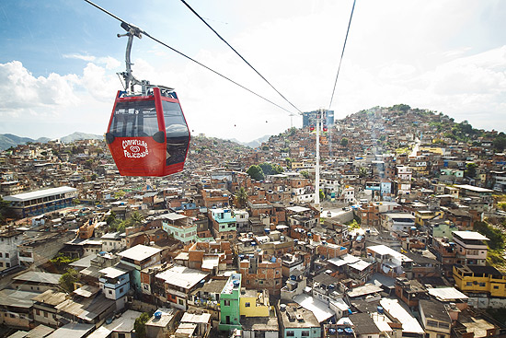 |  | Brief description of scheme | 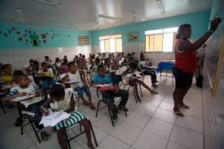
Which problem does it help to solve? | How does it help to solve this problem? | How well will it work? (Evaluation) | Which problem does it help to solve? | How does it help to solve this problem? | How well will it work? (Evaluation)

“For a named city in an MIC/LEDC that you have studied, describe attempts to improve the quality of life there” (7)
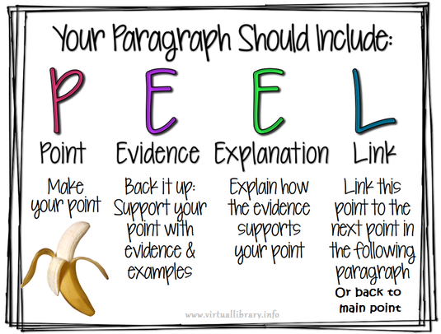
Name of city ______________________________

