Grade 8 – Tourism – The Basics
To be completed with resources embedded on geographypods.com

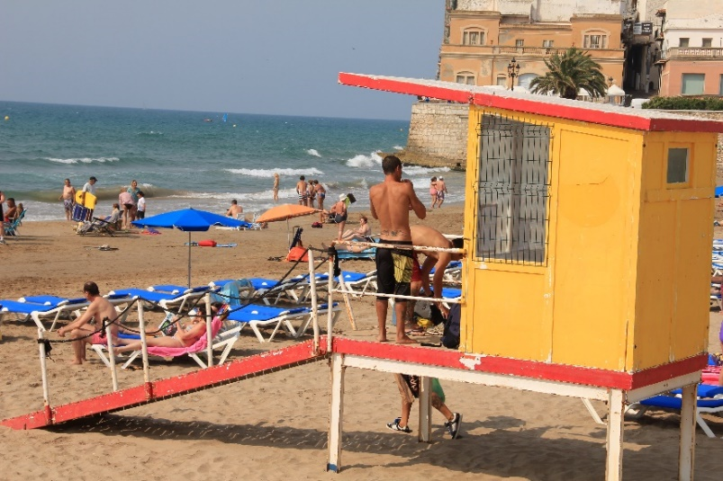

What is tourism? Write your own definition of what tourism is in around 20-30 words.

Personal Geography – Where was the last place you went on holiday? What did you do? How did you get there?

Find the official definition of tourism from the World Tourism Organisation.

Watch the first video on geographypods showing tourism in the early 20th century. Write an account of about 50 words that describes what tourism used to be like, where tourism took place and the activities that tourists undertook whilst on holiday.

Watch the first 6:30 of the second tourism video on geographypods showing modern day tourism. Write an account of 50 words that describes what tourism is now like, where tourism takes place and the activities that tourists undertake whilst on holiday.

Now think back to your timeline work on global tourism. What factors have led to this change in where tourism takes place and the activities that tourists do?
Where tourism takes place

The change in activities

Impacts of Tourism
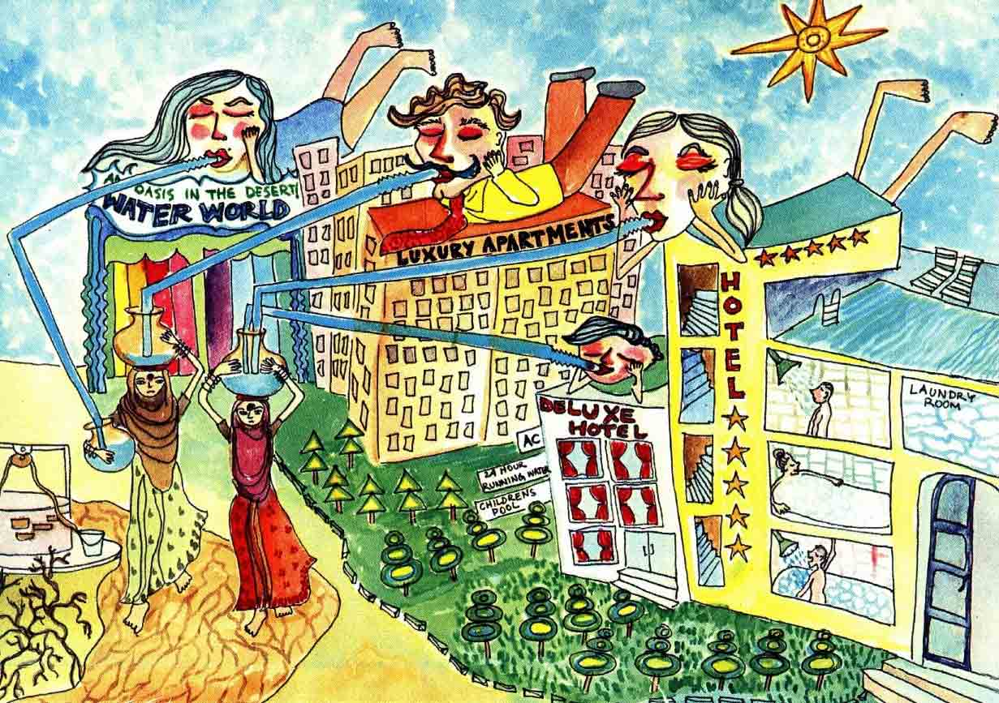
For each of the cartoons beneath, write an interpretation of the issues caused by tourism in the space below.

