G8 Geography - Impact of Tourism on Destinations

How does tourism develop in a destination?
The first to arrive are the ..

Effects of international hotel chains ..

Effects on local people are ..
Padaung women - Check out this video. After watching the video, complete the section below briefly.
Who are these people?

Where do they come from?

Why are they affected by tourism?

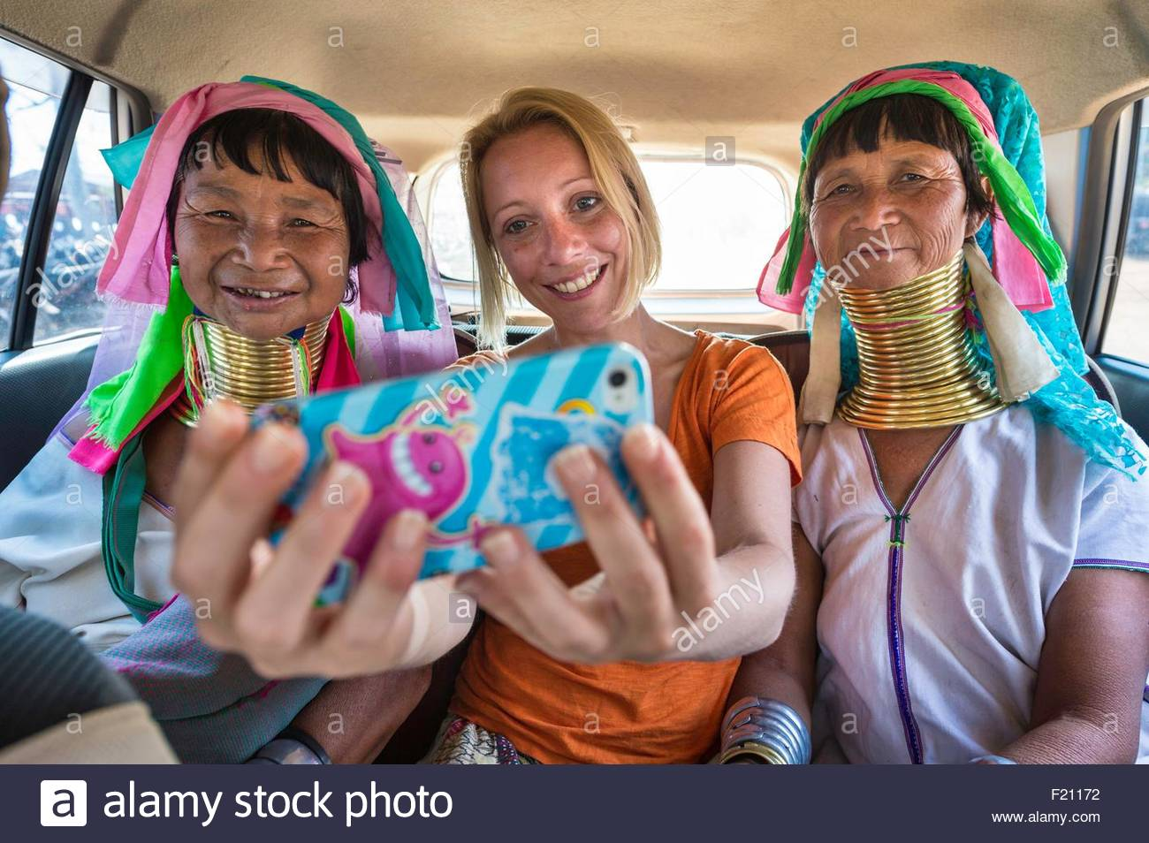

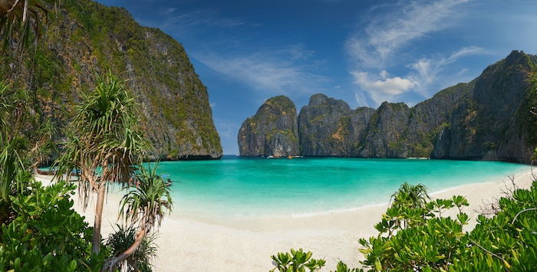
This is Maya Bay in Thailand. It looks idyllic doesn’t it. Paradise on Earth some might say. You may recognize it even if you haven’t been there as it features in a famous Hollywood Movie called ‘The Beach’ with Leonardo DiCaprio. Check out the trailer for the video on YouTube. The link is here.
Do some research into the impacts of the Hollywood film on Maya Bay in Thailand. Google is a good place to start. In the space below outline the impacts of the film on this place and what the authorities have had to do to solve it.

In the space below, paste a more recent image of Maya Bay. Spot the difference!?

In the space below, copy and paste a picture of you on a recent holiday. Annotate around the photo all the positive and (unintentional) negative factors associated with your holiday. You’ll have to think carefully about this.

Location: Date:
Your photo here…

