IGCSE Geography – Life here must be like ……
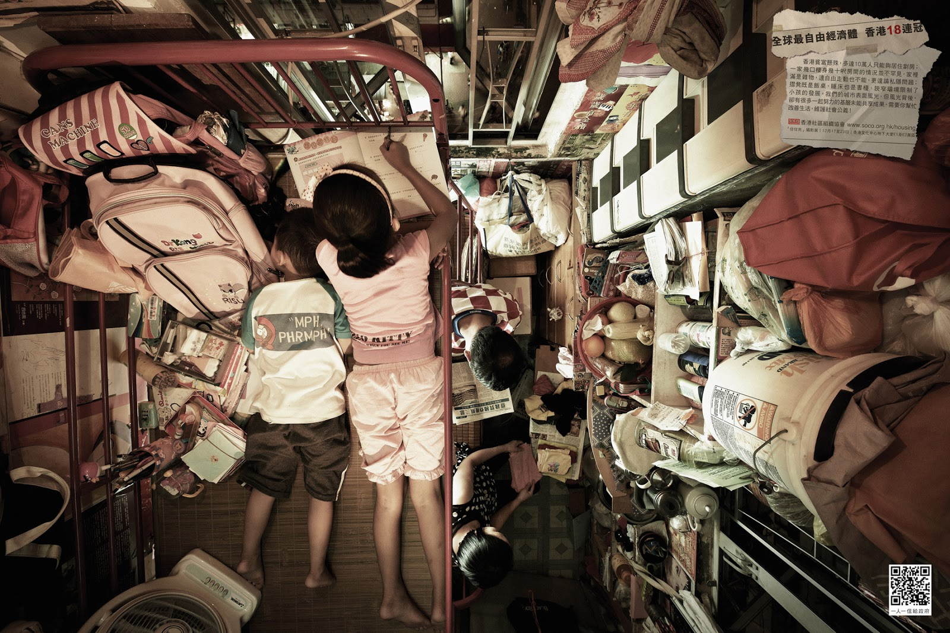
Starter Task – In the space below, write about where this might be, what life may be like there and how it compares to the place where you live.

