IGCSE Geography – What can be done to reduce the impacts of earthquakes?
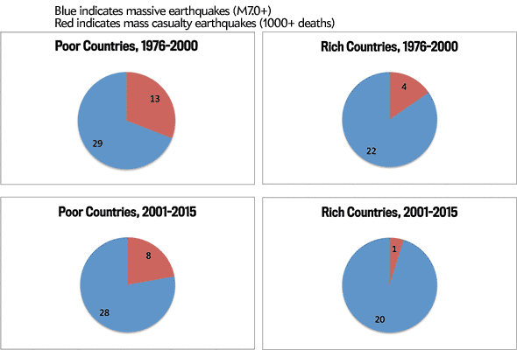
Task 1 – Complete the following questions by studying the pie charts above.

Approximately, how many more times deadly were earthquakes in poor countries than in rich countries (1976-2000)?
Calculate the % reduction in fatalities in poor countries between the 1976-2000 and 2001-2015.
Calculate the % reduction in fatalities in rich countries between the 1976-2000 and 2001-2015.
How many times more people died in poor countries that rich countries from strong earthquakes between 2001-2015?
Can you think of any reasons why this death toll is so much higher in poor countries than in rich countries?

Can We Earthquake Proof a City? – BBC The Inquiry
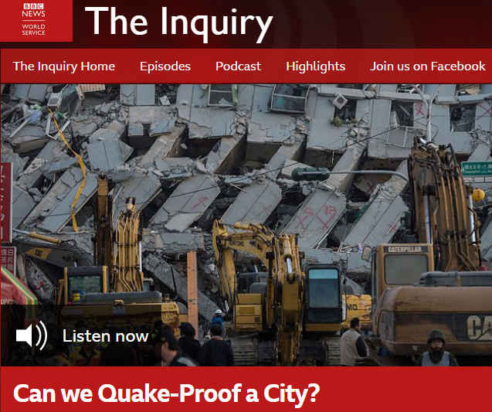
Task 2 – Listen to the BBC Inquiry Podcast embedded on geographypods and complete the activity sheet below.

How many people have died in the last 20 years in earthquakes?
Part 1 - Lessons From The Dead - Dr Emily Sow (researcher)
Where in the world are earthquakes likely to happen?
What causes the most deaths to occur during an earthquake?
What is the worrying trend in the developing world in terms of the building designed?

You will hear details of two 7.6 magnitude earthquakes and two different locations. Fill in the death rate. | Dead in Taiwan -  Dead in Pakistan -
Why is urbanization causing a higher death rate in less developed countries?
Part 2 – High Tech City – David Malott (architect)
Why are tall buildings safer than low to mid height buildings in earthquakes?

Key word: Resonance.
What is the Mile-High Tower and why does David want to build it in Japan?

How long are these buildings designed to last for?

Part 3 – Low Tech City – Martijn Schildkamp (architect)
How has Martijn successfully built schools to be earthquake resistant in Nepal?

How can we use old materials in new ways to build earthquake resisted buildings in poor countries?

Find a picture of a ‘gabion box’ on Google & paste it to the right.

Why is he against the idea of the ‘build quick & cheap’ option?

Part 4 – Lifelines – Dr Lucy Jones (Seismologist USGS)
Why is stopping ‘all earthquake damage’ impossible?

What did Lucy do in 2008?

Note: The video you will hear is hyperlinked into geographypods.
What would happen in the Los Angeles basin in the event of the expected large earthquake?

What would the aftermath of a large earthquake be in Los Angeles?

What does retrofitting old buildings mean?

What other things are being done to prepare for the big quake in Sothern California?
How often does Southern California suffer from big earthquakes?

So, can we earthquake proof cities?

