IGCSE Geography – Reducing Congestion in Toulouse
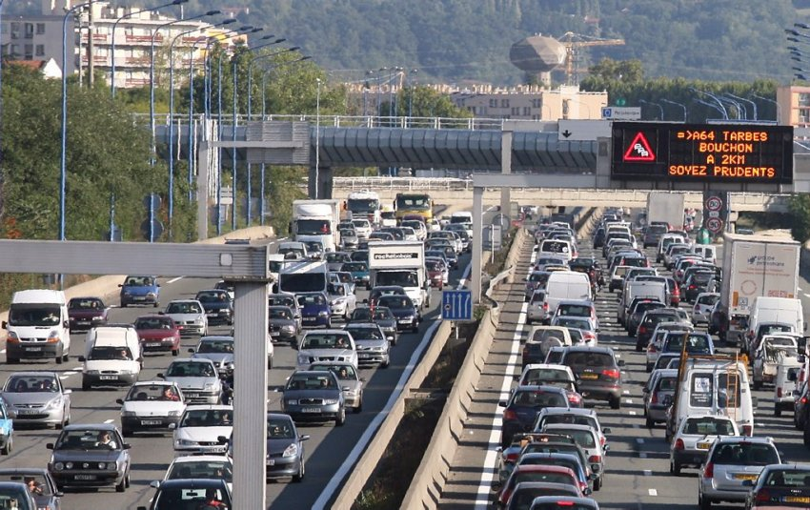
Using the image of the traffic congestion on the Toulouse rocade above, describe the impacts of traffic on the people, the environment and the economy.

Which roads or areas do you or your parents regularly get held up in on the way to school/work?
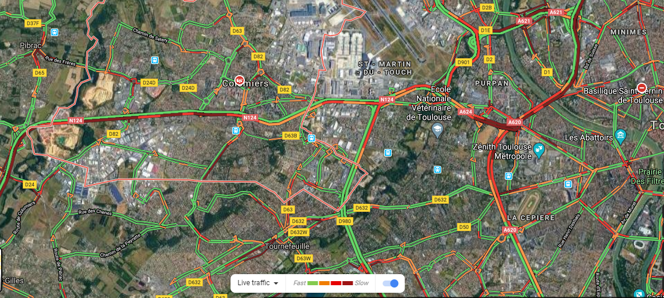

Western Toulouse Google Traffic Map – 02 March 2020.
Mark on the map above the approximate location of our school. If you take car / bus to school, where do you normally get stuck?

The population of Toulouse grows by approximately 20,000 people annually. Many of these people move to Toulouse to work in the aviation industry and live in either the centre of the city or to the west of Toulouse (easy access to Blagnac). What problems might this cause?

Scheme 1 – Covoiturage
Explain how it works

The advantages

The disadvantages

Scheme 2 – Airbus Cycle To Work
Explain how it works

The advantages

The disadvantages

Scheme 3 – Line C Metro (2024)
Explain how it works

The advantages

The disadvantages

