IGCSE Population Policy Propaganda
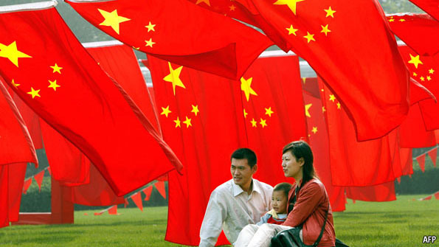
Image 1

Commentary - How the government is trying to persuade their people to conform. Don't forget to explain what they are suggesting by interpreting the imagery.

Image 2

Commentary - How the government is trying to persuade their people to conform. Don't forget to explain what they are suggesting by interpreting the imagery.

Image 3

Commentary - How the government is trying to persuade their people to conform. Don't forget to explain what they are suggesting by interpreting the imagery.

Video Note Taking Task – Use 22 min video embedded on geographypods.

