IGCSE Geography - Population Key Words & Definitions

You will be using Google data bank to help you to find the data for each of these terms in France and in Sierra Leone
Key Term | Definition (copy correct one from list below) | Rate in France | Rate in Sierra Leone
Birth Rate

Death Rate

Fertility Rate

Growth Rate

Infant Mortality Rate

Life Expectancy

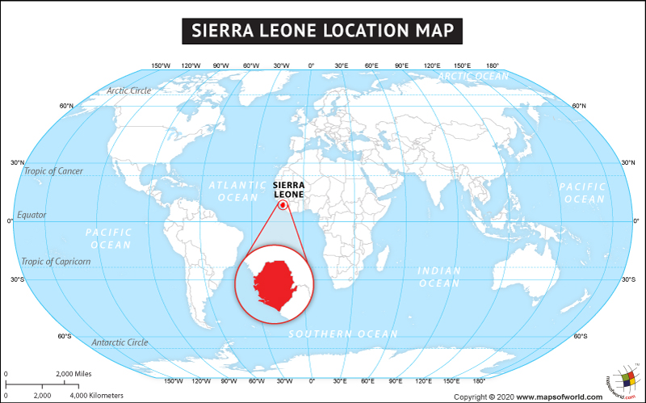
- The average number of children a woman has in her lifetime in a country.
- The average number of deaths per in a year per 1000 people in a country
- The average number of live births in a year per 1000 people in a country
- The average number of years that people expect to live in a country
- The difference between the birth rate and the death rate in a country
- The number of children dying at birth or before their first birthday per 1000 children per year

