IGCSE Geography – Introduction to Globalization
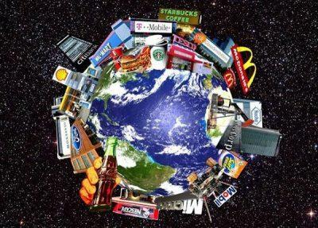
Define the term ‘Globalization’
Globalization is a process of interaction and integration among the people, companies, and governments of different nations, a process driven by international trade and investment and aided by information technology. This process has effects on the environment, on culture, on political systems, on economic development and prosperity, and on human physical well-being in societies around the world.

Task 1 - Use the two images on geographypods to explain the origins of the process of globalization. Make sure you make reference to the key character who is central in the artwork.
‘Godfather of Globalization ??
Task 2 is completed on a separate sheet

Task 3 - Click on this link to be taken to a BBC Bitesize resource about the positive &negative impacts of Globalization. Make a note of these on your worksheet.

Positive Impacts of Globalization | Negative Impacts of Globalization

Task 4 - Study the diagram and map on geographypods. The show where parts from an A380 aircraft come from and the operations of Airbus around the world. Then watch the video on geographypods.

Outline the following:
- What has been the role of technology in enabling Airbus to operate across the world?
- What economic factors have contributed to their growth and spread?
- What have the impacts at a local, national and global scale been?
