IGCSE Geography – Why do people live so close to the Nevado Del Ruiz volcano?

Why do people live so close to active and potentially deadly volcanoes? Although Armero was over 40km from the summit of Nevado Del Ruiz, it was still a danger to them. Armero was never rebuilt after the 1985 tragedy. Instead, the survivors were relocated to the towns of Guayabal and Lérida, rendering Armero a ghost town. You will see this on the Google 360° images on geographypods.

The relief (shape of the land) & water supply | 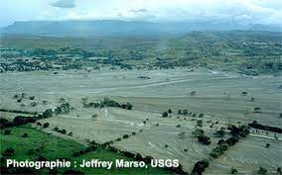  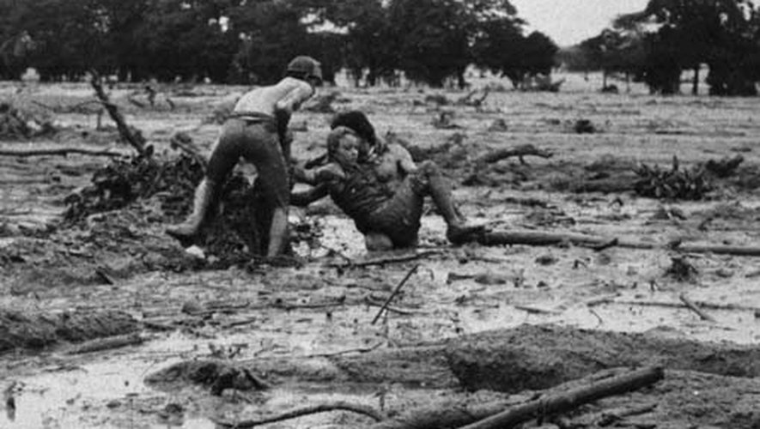 | The climate of the area
Farming possibilities |  | Accessibility

