IGCSE Geography - Weathering
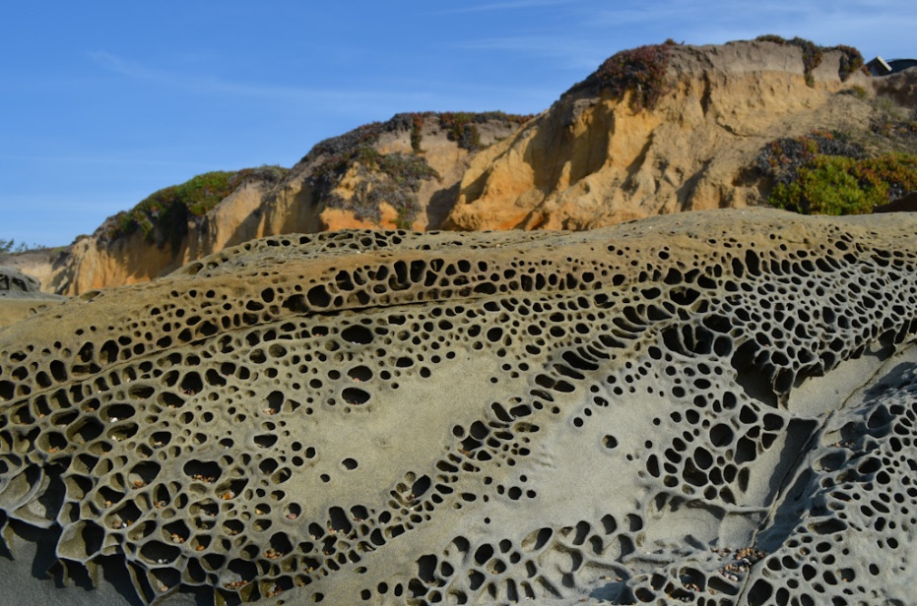

Weathering is

Chemical weathering is

Physical or mechanical weathering is

Biological weathering is

Notes from the BBC Bitesize Video

Factsheet on the different types of weathering here (from Greenfield Geography)

Create your factsheet in the space below:

