IGCSE Geography – Population Growth & Distribution
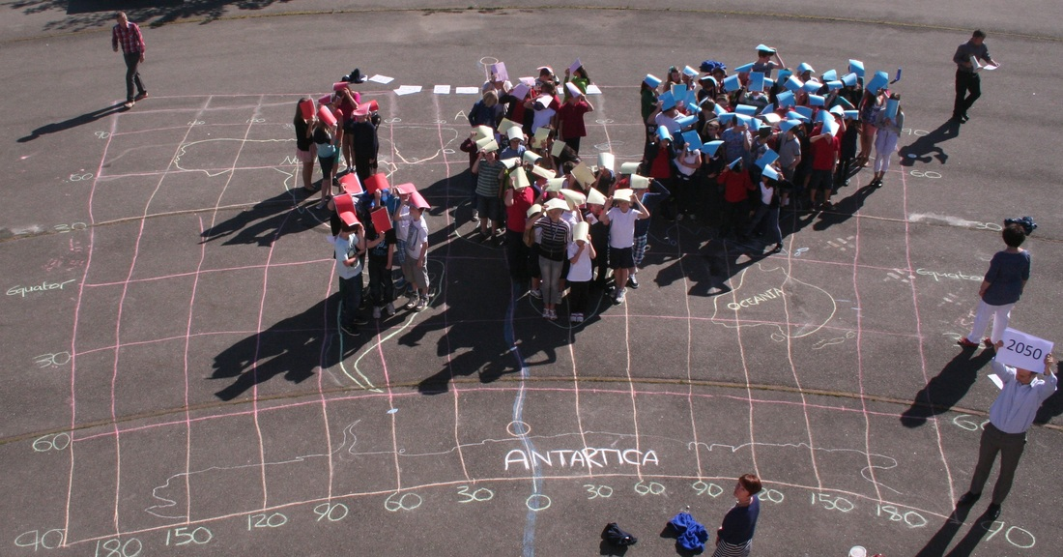
Task 1 – Using Geographypods, note down the five reasons why the population growth rate has started to slow.
1

2

3

4

5

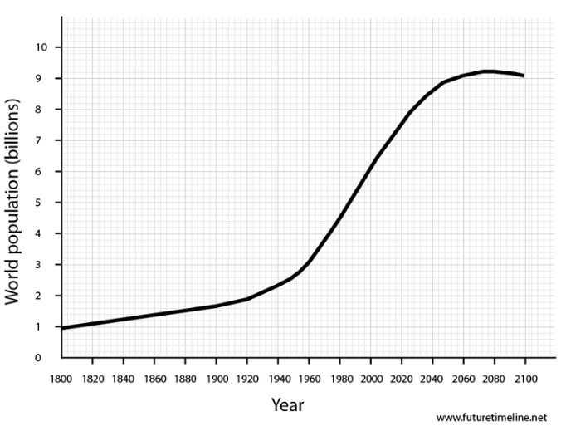

Task 2 –
Task 2i. Study the graphic and data on geographypods. In the space below, identify the three most populous countries in this circle.

ii. Try to identify three issues that could be caused by having such a high concentration of population in this area (circle).
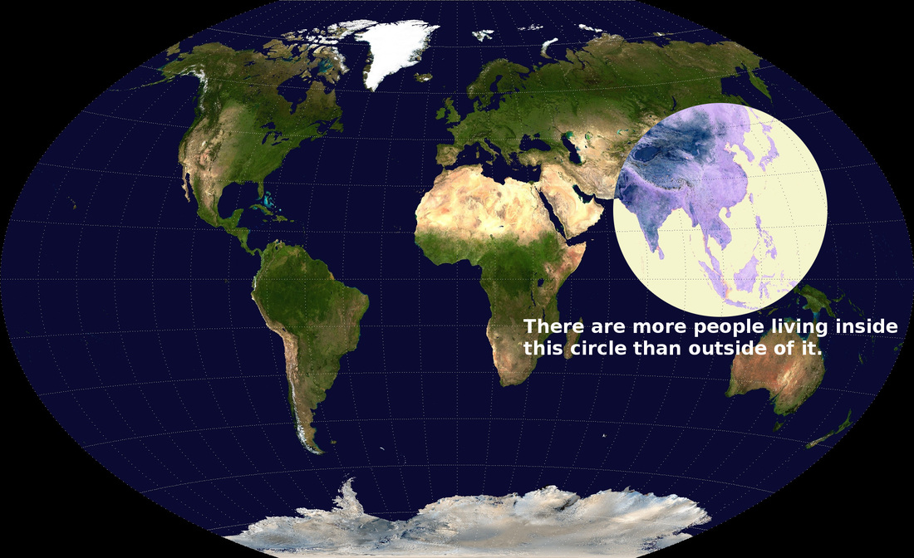
Country 1:

Country 2:

Country 3:

Issue 1:

Issue 2:

Issue 3:

Task 3 - Define ‘Population Distribution’

Task 4 - Define ‘Population Density’

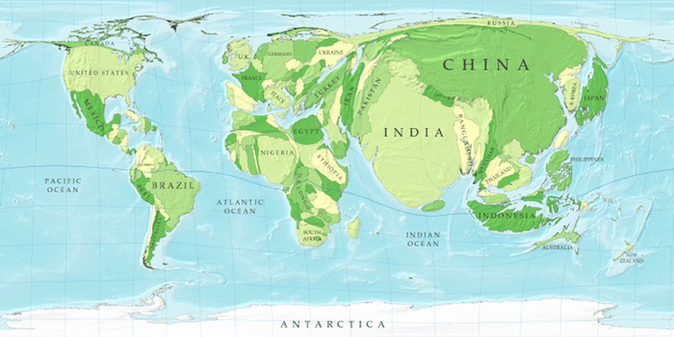

Task 5 - Write a good quality description of the distribution of the world’s most populous countries. Try to identify countries that have swelled hugely and those that have almost disappeared.

Task 6 - Population density is influenced by a number of factors. Try to explain why the following factors are important in determining whether people can survive in an area or not:

Factor | Explain how it influences population density | Example of place in the world where it causes high population density | Example of place in the world where it causes low population density
Availability of freshwater.

Communications (roads, railways, airports).

Proximity to the coastline.
Cities and their opportunities.

The shape (relief) of the land.

Task 7 - Using the embedded map below, label (using text boxes & arrows) the two different areas of the world where each of the five factors above is / is not available.

