IGCSE Geography – Low Population Growth Rate in China
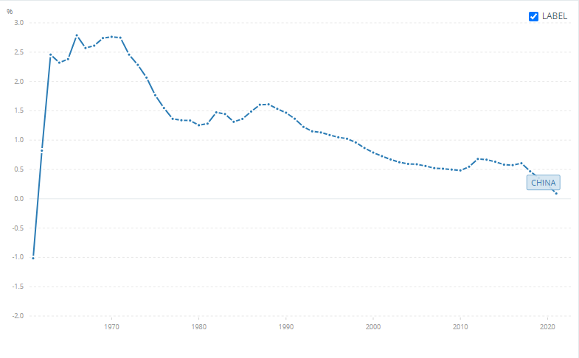
Study the graph carefully on geographypods. It shows population growth rate in China as a % growth rate. It is interactive so you can select certain years and it will give your specific data.

Describe the rate of population growth in China between 1960 and 1970.

Using this site, state the total population of China in 1960 & 1970.
1960 | 1970

Describe the rate of population growth in China between 1971 and 2000.

Using this site, state the total population of China in 1980 & 2000.
1980 | 2000

Describe the rate of population growth in China between 2001 and 2021.

Using this site, state the total population of China in 2010 & 2021.
2010 | 2021

The population growth rate chart % is showing a decline, but the total population graph shows an increase in population in China. How can this happen?

What is likely to happen to the population of China by the year 2102?

On your graph on the first page of the worksheet, in the correct place, mark on ‘1979 – The One Child Policy’.

