IGCSE Geography – Global Food Supply & Shortages

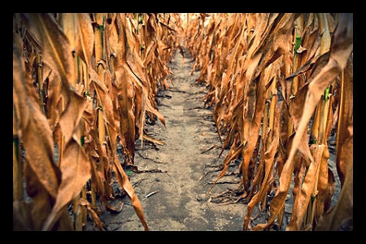

Task 1 – In the space above, create a spider diagram to show the factors that can combine to cause the price of food to rise and subsequently cause food shortage.

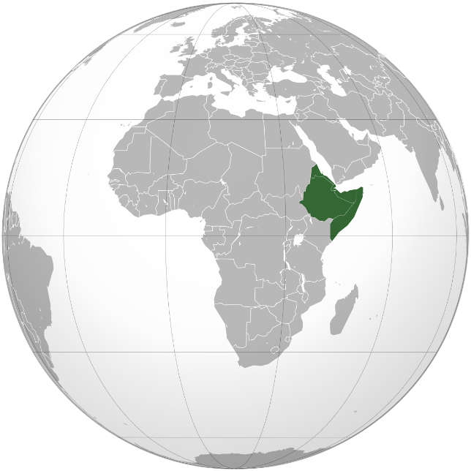

Describe the location of the Horn of Africa region and name the four countries that are found there.

Excluding Uganda & Kenya, calculate the total number of people in crisis levels of food security in 2017
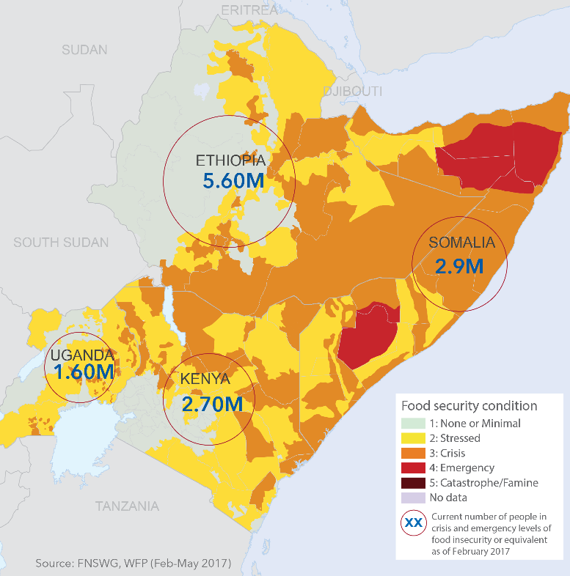

Click here to be taken to a Google 360° image. Describe the evidence here which tells you that this is an area of severe food shortage.

Using both BBC videos embedded on geographypods, and this France 24 article, write down some of the causes and effects of the food shortages in the Horn of Africa.
Causes (human & physical) | Effects (people & the environment)

How does this look in the Paper 1 exam?
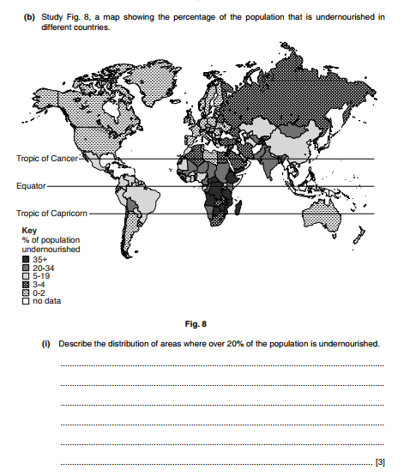

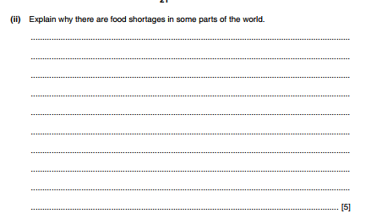

(7)

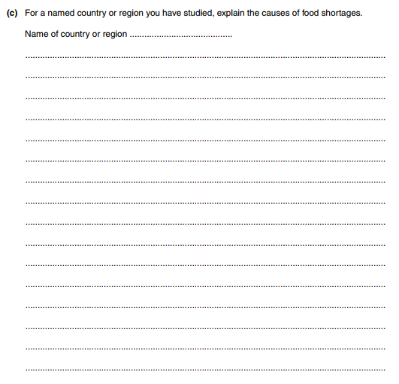
(7)

IGCSE Geography – Food Aid

Watch the first WFP video to the right and take notes on the following:
i. How many people die per day from hunger?

ii. Of that total, how many are children?

iii. What does WFP stand for and who is it run by?

iv. How does the WFP distribute its food?

v. How else does the WFP help in famine prone areas?
​

vi. How many people does WFP feed per year?

Watch the second WFP video to the right and describe how the WFP get food to people in severe need. Explain why planes are not the preferred method.

