IGCSE Geography - Protecting the Coastline – Hard & Soft Engineering Approaches

Part 1 – Hard Engineering Approaches - A technique involving the construction of significant man-made structures to manage the coastline. e.g. sea walls and rock armour. They look artificial but can be constructed from either man-made or naturally occurring materials.

Image | How it works | Advantage | Disadvantage
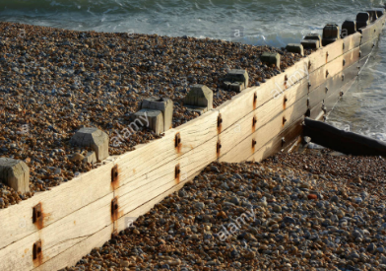 | Groyne: Wooden or stone made barrier aimed at blocking the movement of beach sediment by LSD. Traps sand on the updrift side of the groyne. | Very effective and preserves beach sediment, therefore protecting tourism economy of seaside resorts like Sitges (Spain). | They don’t look very natural and can make the beach very difficult to travel over. They cost a lot of money, for example €230,000 per wooden groyne. Wood decays over time and so many places are moving to boulders.

Part 2 – Soft Engineering Approaches - A technique involving the construction of more environmentally friendly, less damaging, and arguably more sustainable management solutions. e.g. beach nourishment or managed retreat

Image | How it works | Advantage | Disadvantage

