IGCSE Geography – Agricultural Systems
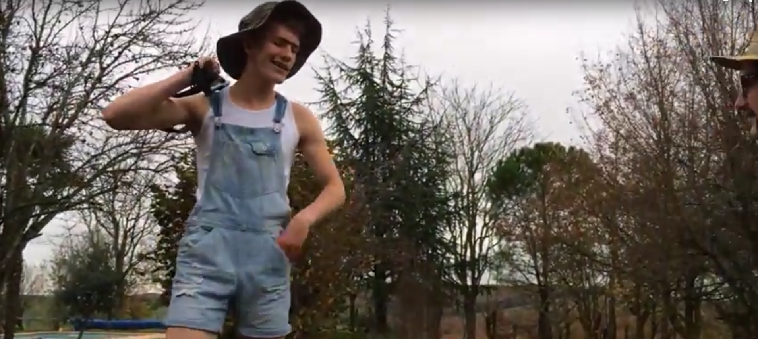
The first thing you need to remember is that farming and agriculture is very different from the character above and we have moved a long way from the days of small scale subsistence farming to the modern large scale commercial farms that keep us stocked with food and drink 365 days a year. Be prepared for some shocks!

Task 1 – Using the link on geographypods, complete the key words definitions below.
Agriculture
Aquaculture
Pastoral Farming
Arable Farming
Mixed Farming
Livestock
Subsistence Farming
Sedentary Farming
Shifting Cultivation
Commercial Farming
Hectare
Yield
Intensive Farming
Extensive Farming

