IGCSE Geography – How Rivers Change From Source to Mouth
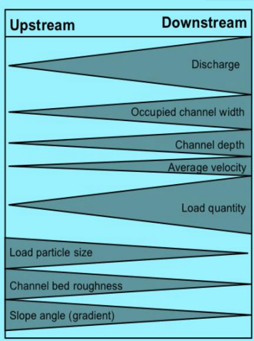
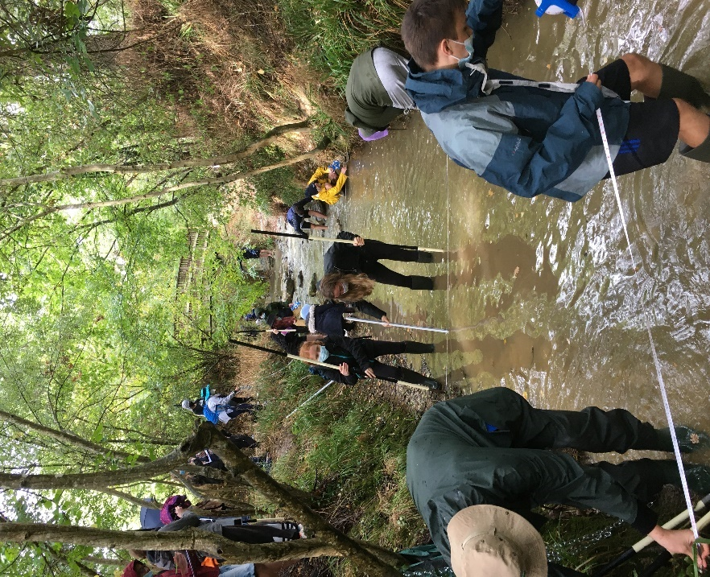

Process | Definition | How it changes as the river travels downstream. | Equipment needed and any mathematical calculations.
Discharge |  |  | We measure discharge by multiplying the cross sectional area of the river by the velocity. This will be in cumecs (cubic metres per second)
Occupied Channel Width
Channel Depth |  |  | We divide the total width of the river by 10 (e.g 3 meter wide river = 0.3m). We then measure the depth at 0.3m intervals across the river.
Average Velocity
Load Quantity |  |  | We do not need to measure this on our Aussonnelle fieldwork
Load Particle Size
Channel Bed Roughness
Slope Angle (Gradient). | The angle between different points of the river.

Equipment for our fieldwork.
Photo | Name of equipment & used to measure? | How we use it.
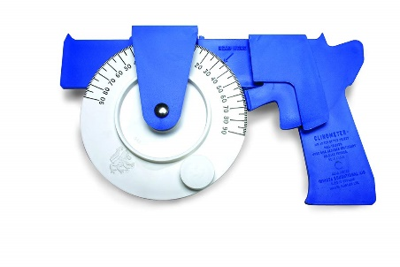 | Clinometer. Used to measure the angle of a slope in ° (degrees. | *Make sure that both poles are in the centre of the river and vertical and the right way up. Place your clinometer against the height mark on your pole and look through the sight, adjusting the angle of the clinometer until you are looking directly at the height mark on the other pole. Release the trigger and read the angle.
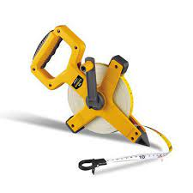 | Tape measure (10 metre). Used to measure the occupied channel width and the bank full width of the river. Used to measure distances between ranging poles | Stretch the tape across the river and make sure that it is tight. The 0cm should be where you want to start the measurement and your partner can measure the total in metres. Easy!
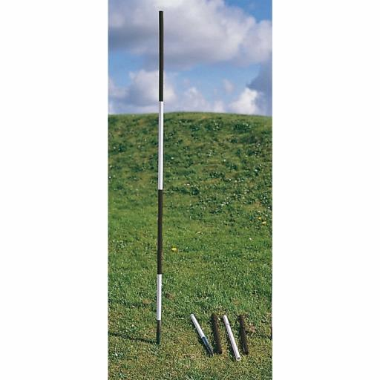 | Ranging Pole used to measure the velocity of the river between two points. Used to measure the gradients of the river between two points. | To measure gradient, place one ranging pole in the river with a person and a clinometer. Then place the other exactly 10 metres downstream and in full view of the first one (with a friend holding it). Then follow instructions for the clinometer* above.
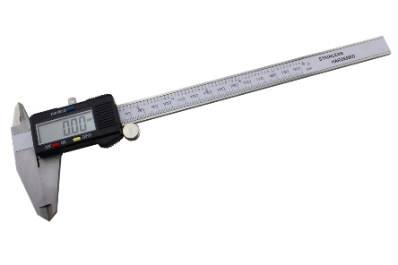 | Vernier caliper (in cm) - This piece of equipment is used for measuring the size of the pebbles on the river bed. | You take the pebble and place it between the caliper and read off the length either on the digital display or the ruler measurer on the top. The measurement must be in metres so if the pebble is 5cm across, your measurement will be 0.05m.
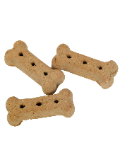 | Dog biscuits used to measure the velocity of the river. | One the same 10 metre stretch where you measured the gradient, drop a dog biscuit into the water next to the ranging pole upstream. Start your stopwatch. Record in seconds the time it takes to reach the second ranging pole. Repeat three times and take the average in metres / second.

