IGCSE Geography – Changing Rivers
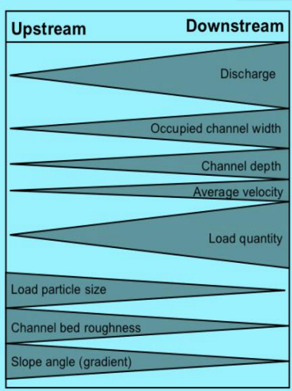

Process | Definition | How could we measure this?
Discharge
Occupied Channel Width
Channel Depth
Average Velocity
Load Quantity
Load Particle Size
Channel Bed Roughness
Slope Angle (Gradient).

